Final Report

Date: 12/04/2022

**CECS551 Advanced Artificial Intelligence Final Project**

California State University Long Beach



Group ~ 08

Submitted To:

Prof. Mahshid Fardadi

Submitted By:

Akshada Thube

Krishna Sai Mullangi

Smith Elias Dabreo

Thamma Bhanu Sumanth Reddy

Waseem Farooq Shaik

**Table of contents**

Correlation histogram of the features 4

Correlation Matrix heatmap 4

Feature Importance 5

Visualizing Weekly and Monthly sales patterns for the top 35% of the department sales 6

Investigate the relationship between weekly sales over CPI and unemployment for the first 10 stores. 9

Investigate the impact of various types of discounts on the overall sales 12

2.1.2 Analyze the dataset for CECS551_dataset_02 18

Sprint 2 19

Colab URLs: 20

CECS551 Dataset 01 Problem Statement: 20

1. Design a prediction model to forecast the weekly sales across first ten stores. 21

2. Multi-label classification problem 25

a. Ensemble models 25

I. Average 27

II. Weighted Average 27

III. Voting 27

IV. Stacking 28

b. Recurrent Neural Network 29

c. Convolutional Neural Network (CNN) 33

CECS551 Dataset 02 Problem Statement: 40

Sprint 3 61

We analyze the graph for each class: 66

References 72

**Section1: Data Visualization**

**Dataset 01 Google Collab Link:**

[**https://colab.research.google.com/drive/1oUxGCwvhSobMNolhUN71oHdAT9IcTIjX?usp=sharing**](https://colab.research.google.com/drive/1oUxGCwvhSobMNolhUN71oHdAT9IcTIjX?usp=sharing)

*Tableau Links included below

Snapshot of all the merged data from Dataset 01

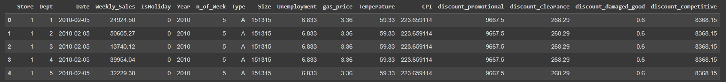

*Figure 1: Head of the merged dataset01*

After concatenating all the data and handling missing values by using fillna() & dropna() functions. Our dataset is ready for visualization with 339369 rows and 15 columns

Generating Correlation values w.r.t. Weekly_Sales

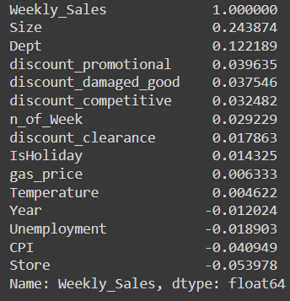

*Figure 2: Correlation values w.r.t weekly sales*

We observe that most of the features are weakly correlated to Weekly_Sales. The highest association we observe is for size which is a positive correlation of 0.24

Correlation histogram of the features

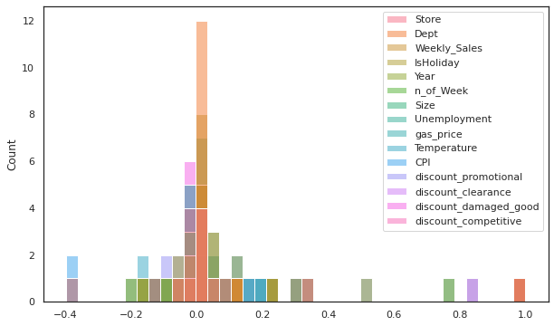

*Figure 3: Correlation histogram of features from dataset01*

The histogram showcases that most of the features have a correlation between the values -0.2 to 0.2 with very few outliers.

## Correlation Matrix heatmap

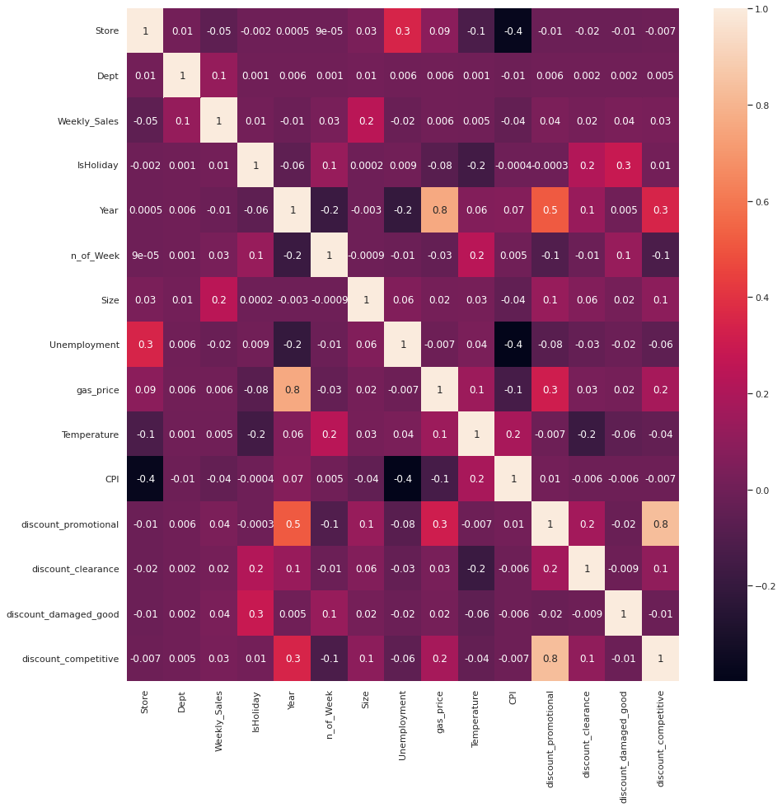

*Figure 4 Correlation heatmap of features*

This heatmap allows us to analyze the inter correlation between all the features which helps us give a better peek into the dataset. It is observed that Unemployment and CPI have a medium Negative Correlation (We can visualize their relationship in a graph later). I.e. Higher unemployment rate led to a lower Consumer Price Index (CPI) and vice versa. Similarly, Gas prices affected the promotional discounts. We could see an increase in gas prices as the years went on.

## Feature Importance

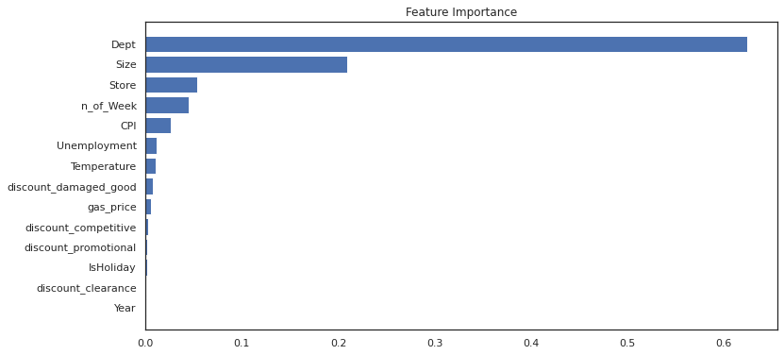

*Figure 5: Feature importance using random forest regressor*

We extracted the feature importance by training a random forest regressor model on the dataset. According to this horizontal bar plot Department is one of the most important features affecting weekly sales. Followed by store size and store number. A feature like year has little to no importance.

## Visualizing Weekly and Monthly sales patterns for the **top 35% of the department sales**

1. Weekly_Sales for all the Stores

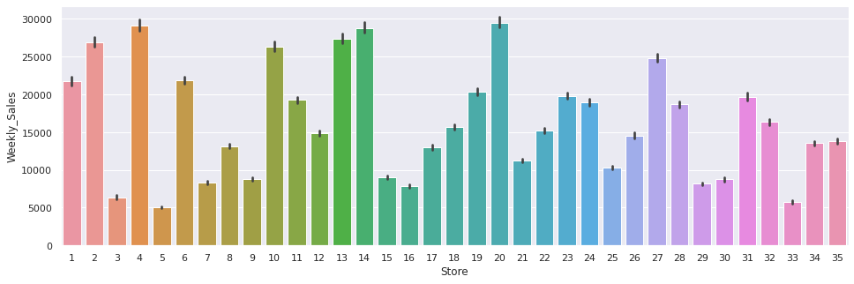

*Figure 6: Weekly sales for all stores (1-35)*

Store no. 4, 10,13,14 & 20 performed exceptionally well in terms of Weekly_sales. Whereas Store no. 3, 5 & 33 didn't amount to many sales.

1. Visualizing the weekly_Sales patterns for the top 35% of the Sales w.r.t. All the Departments for only the first 10 stores.

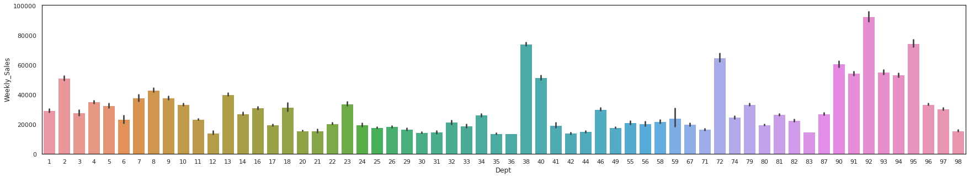

*Figure 7 Weekly sales patterns for top 35% sales*

We observe that out of 99 departments some departments are missing for eg: 19 & 47. This is because these departments did not have the top 35% of sales. Additionally, departments 92 and 38 performed exceptionally well and departments 36 & 42 had Weekly_sales at the lower spectrum.

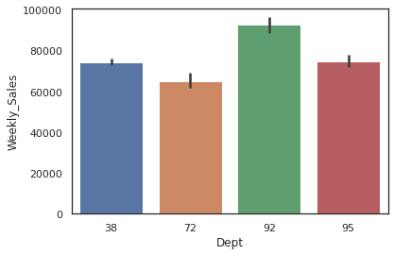

*Figure 8 Top 4 departments with the highest weekly sales*

We selected the top 4 best performing departments from the previous bar plot containing all the departments. (Dept: 38, 72, 92 & 95). Department 92 had the highest recorded Weekly_Sales across the first 10 stores for the top 35%.

1. Weekly sales for each month in the years 2010, 2011, and 2012.

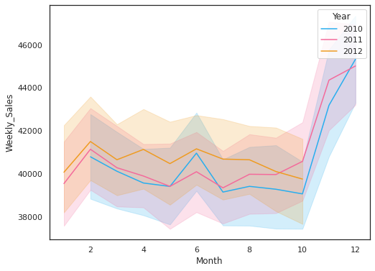

*Figure 9 top 35% weekly sales for each month for all the years (2010-2012)*

The above line plot showcases those sales soared after the month of October for both 2010 & 2011. We can assume that due to vacations like Thanksgiving, fall break, and Christmas there were more people buying the products leading to higher sales in that time period. For the rest of the months, we can see consistent sales for all 3 years. We can also see that overall sales increased after each year. We do not have any data for the months after October for the year 2012 and we are missing data for January 2010. A sudden spike in sales is observed in the months of February & June for all 3 years.

1. Highest Sales made by a store

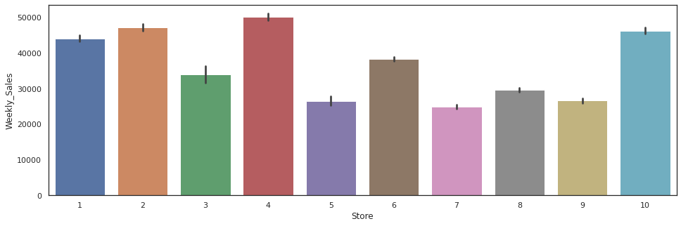

*Figure 10: Highest sales made by a store*

The above bar plot depicts Store 4 had the most Sales (Around 50000) within the top 35% of weekly sales very closely followed by stores 2 & 10(under 50000). Store 7 performed the worst in terms of sales (below 25000)

1. Scatter plot for all the Stores w.r.t. Weekly_Sales

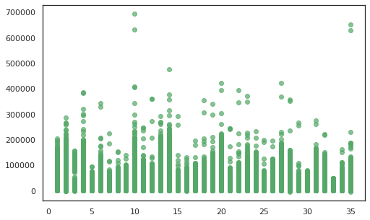

*Figure 11: Scatter plot of store vs weekly sales*

This graph is a bit different from the bar plot in 1. B as here we can observe stores achieving sales of the highest degree. For stores 10 & 35 sales reached between 60,000 to 70,000 for a week.

## Investigate the relationship between weekly sales over CPI and unemployment for the first 10 stores.

1. Unemployment rate per store for the first 10 stores

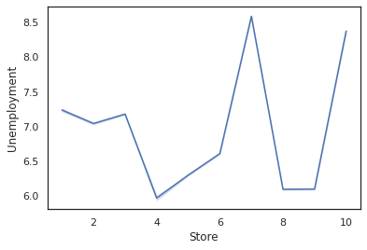

*Figure 12: Unemployment rate per store*

Stores 7 & 10 had the highest unemployment rate of around 8.5. On the other hand Store, 4 had the lowest unemployment rate of 6.0

1. Unemployment rate density

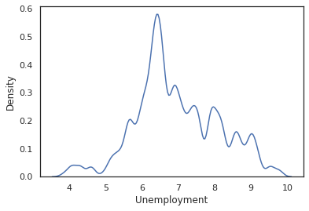

*Figure 13: Unemployment density*

For around 50% of the data the unemployment rate lies around 6.0 to 7.0.

1. Relationship between 2 variables x = Unemployment and

y = Weekly_Sales

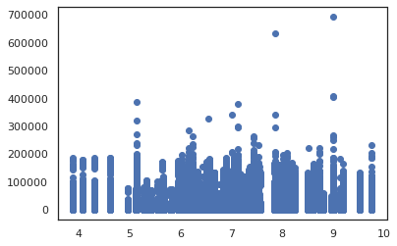

*Figure 14: Unemployment Vs Weekly Sales*

The above plot suggests the absence of a linear relationship between the two variables. This is further proved by the correlation matrix where we observe a minimal negative correlation between Weekly sales and the Unemployment rate

4. Relationship between 2 variables x = CPI and y = Weekly_Sales

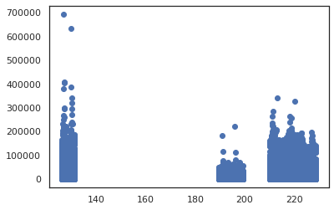

*Figure 15: CPI Vs Weekly Sales*

The above scatter plot depicts that there were no sales when The Consumer Price Index (CPI) was between 140 and 180. CPI under 140 had higher Weekly_Sales and CPI between 190-200 had the worst sales.

5. Rel-plot for CPI with respect to Unemployment

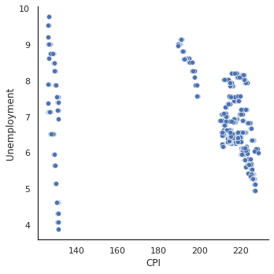

*Figure 16: CPI Vs Unemployment*

From the correlation matrix we observed a medium negative correlation between CPI and Unemployment. Therefore, we Vizualize the relation between CPI and Unemployment. We observe a similar pattern as the CPIxSales graph. Most of the data points are saturated at above 200 CPI and between 5.0 and 8.0 Unemployment rate.

6. Number of Stores per each type

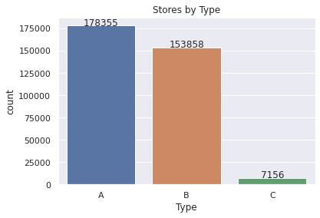

*Figure 17: Number of stores per type*

As we can see from the above graph, for the three types of stores A, B, and C. Type A has the highest number of stores (178355) followed by type B (153858) with a lesser number of stores and type C has extremely least number of stores.

## Investigate the impact of various types of discounts on the overall sales

Understanding the data distribution for all the given discounts by plotting their density.

Data Distribution for discount_clearance

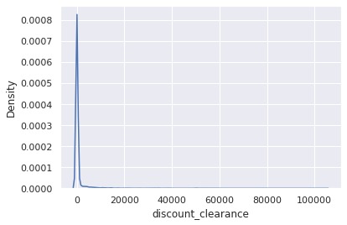

*Figure 18: Clearance discounts data distribution*

We can see the above graph that most of the discounts given were between 0 to 2000.

Data Distribution for discount_promotional

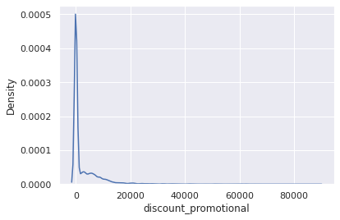

*Figure 19: Promotional discounts data distribution*

We can see the above graph that most of the discounts given were between 0 to 2000 followed by 2000 to 18000.

Data Distribution for discount_damaged_good

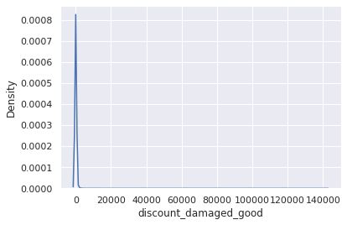

*Figure 20: Damaged goods discount data distribution*

We can see the above graph that most of the discounts given were between 0 to 1000

Data Distribution for discount_competetive

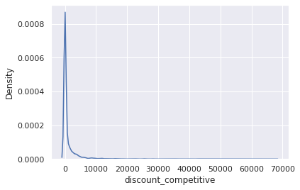

*Figure 20: Competitive discounts data distribution*

We can see the above graph that most of the discounts given were between 0 to 4000

1. Analyzing the impact of various discounts on the overall sales for all the stores:

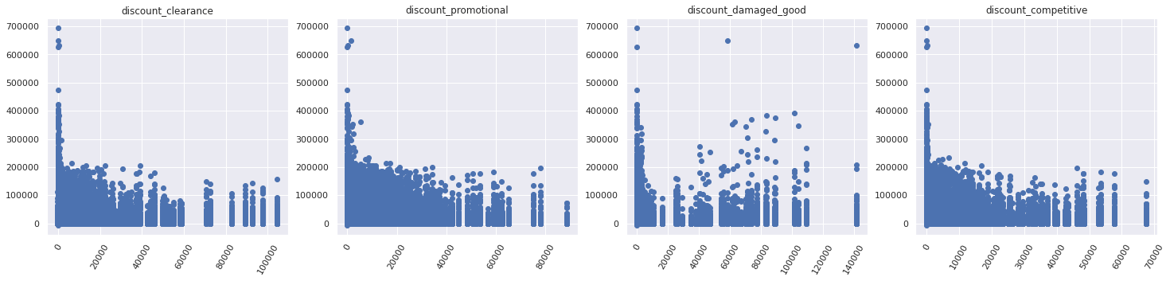

*Figure 21: Discount types Vs Sales*

For all the stores:

1. Discount_clearance: Sales with clearance discount, mostly between 0 to 50,000 discount was given. With many sales discounts being close to 0.
2. Discount_promotional: Similar discount pattern was observed. However, we see sizable sales for discounts between 40,00 to 70,000
3. Discount_damaged_good: We see either very low discounts or between 50,000 to 80,000. With the highest ever discounts given at 140000 across all discounts.
4. Discount_competetive: Consistent sales are observed across discounts raniging between 0 to 50,000.

2. Analyzing the impact of various discounts on the Sales of top 30% of the best-performing stores:

Fetching the dataset for the top 30% of the best-performing and analyzing the impact of various discounts on the top 30% of the best performing stores.

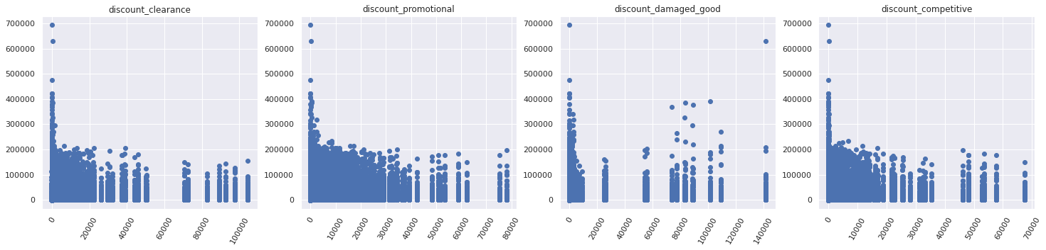

*Figure 22: Discount types Vs sales(Top 30%)*

1. Discount_clearance: Sales with clearance discount, mostly between 0 to 20,000 discount was given. With many sales discounts being close to 0.
2. Discount_promotional: Most Sales between 0 to 40,000 discount was given.
3. Discount_damaged_good: We see either very low discounts or between 70,000 to 110,000. With the highest ever discounts given at 140000 across all discounts.
4. Discount_competetive: Consistent sales are observed across discounts ranging between 0 to 20,000.

3. Analyzing the impact of various discounts on the Sales of the bottom 30% of the least performing stores:

Fetching the dataset for the bottom 30% of the best performing and analyzing the impact of various discounts on the bottom 30% of the best performing stores.

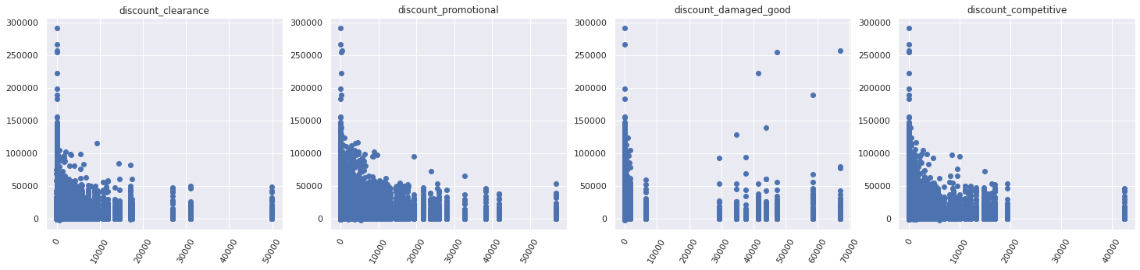

*Figure 23: Discount types Vs sales (Bottom 30%)*

1. Discount_clearance: Sales with clearance discount, mostly between 0 to 20,000 discount was given. With many sales discounts being close to 0.
2. Discount_promotional: Most Sales between 0 to 40,000 discount was given.
3. Discount_damaged_good: We see most sales with extremely low discounts or some sales between 30,000 to 70,000. With highest ever discounts given at 70,00 across all discounts.
4. Discount_competetive: Consistent sales are observed across discounts running between 0 to 18,000.

**After Understanding the above 3 plotted Discounts x Weekly_Sales Scatterplots,**

**We can successfully infer that Promotional Discounts mattered a lot for driving sales as we can see the top 30% best performing stores offered more promotional discounts. Additionally, the Bottom 30% of stores didn't give many discounts on Damaged goods which led to less sales.**

* **Recommendation to increase sales**

If the stores want to increase sales, they should focus on providing customers with Promotional and damaged goods discounts rather that Clearance and Competitive discounts.

**1.E.** **Identifying the impact on Weekly_Sales by external factors:**

**Original Task:** Identify the products which are highly impacted by external factors: “temperature”, “gas price”, and “holiday”. Is there any correlation between overall sales and holiday?

**->**Since, the dataset does not contain any products, we analyze the impact of external factors like temperature, gas price, and holiday on overall weekly_sales.

1. Correlation between overall sales and isHoliday

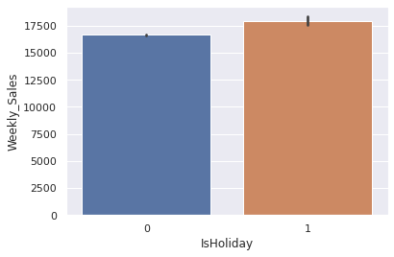

*Figure 24: Correlation plot of Sales Vs Holiday*

We observed an increase of around 10% in sales for weeks with holidays. Therefore, Holidays have a positive impact on sales ans stores should expect more sales during holidays.

There is a Slight positive correlation between Weekly_Sales and Holidays.

1. Scatter plot of gas_price vs Weekly_Sales

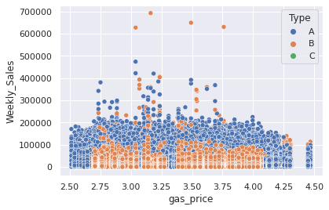

*Figure 25: Gas Vs Weekly Sales*

We saw a plummeting in sales after the price of gas exceeded by $4.25. Additionally, Type A had higher sales compared to other types. For the most part, Gas prices won't have a major impact on sales.

1. Scatter plot of Temperature vs Weekly_Sales

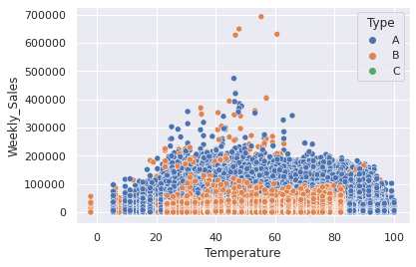

*Figure 26: Temperature Vs Weekly Sales*

At extreme temperatures, i.e, under 20 and over 80, we saw a decrease in sales, especially for type B stores. The highest sales can be seen between the temperature range of 35 to 70. Medium-temperature weather can be a favorable external factor for driving weekly sales.

### **2.1.2** **Analyze the dataset for CECS551_dataset_02**

Data Visualization was done on **CECS551_dataset_02** using Tableau and we got 32 charts depending on various categories. We’ve also attached the public dashboard link, along with the ppt generated for the sheets and the workbook.

Data relationships:

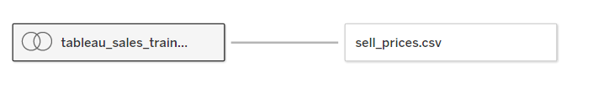

*Figure 27*

Example hierarchy:

Item1 - day 1 - date - price

Item2 - day 2 - date - price

Joined table with historical sales data and calendar and then added a logical relationship to the result table and sell_prices table which has selling price records.

All the important charts have been published on the public server.

First dashboard link: <https://public.tableau.com/app/profile/charlesxavier/viz/dashboard-1-AI/Sprint1Visualization?publish=yes>

Second dashboard link: <https://public.tableau.com/app/profile/charlesxavier/viz/dashboard-2-AI/SalesDataVisualization?publish=yes>

Third dashboard link:

<https://public.tableau.com/app/profile/charlesxavier/viz/dashboard-3-AI/Dashboard4?publish=yes>

**All 32 Results are in .PPTX submitted in the sprint 1 dropbox.**

## **Sprint 2**

## Colab URLs:

**Dataset 01 Task 1 (Regression):** [**https://colab.research.google.com/drive/1VnZtwgCaLxNFkvrHsY7D50rXn4ruEHMJ?usp=sharing**](https://colab.research.google.com/drive/1VnZtwgCaLxNFkvrHsY7D50rXn4ruEHMJ?usp=sharing)

**Dataset 01 Task 2 (Classification):**

[**https://colab.research.google.com/drive/1cjs6zG9-nmX6-vkOPrg898pvkHdfmIFi?usp=sharing**](https://colab.research.google.com/drive/1cjs6zG9-nmX6-vkOPrg898pvkHdfmIFi?usp=sharing)

**Dataset 02 (Time Series):**

[**https://colab.research.google.com/drive/1nNf8MsMWMoWDKGY1tYl9ExgPfl8TYgqB#scrollTo=Qt84Nq2Fkq9A**](https://colab.research.google.com/drive/1nNf8MsMWMoWDKGY1tYl9ExgPfl8TYgqB#scrollTo=Qt84Nq2Fkq9A)

## CECS551 Dataset 01 Problem Statement:

### 1. Design a prediction model to forecast the weekly sales across first ten stores.

Use the same model to make predictions for store_11_35. There are external variables such as gas price, holidays, unemployment, and temperature for the given dataset. Evaluate the impact of these external variables on the accuracy of the model (do they help improve the accuracy?). Plot the relevant graphs.

* 1. Begin with Linear regression model to forecast the weekly sales using the given features.
  2. Create the following machine learning models: ARIMA, Ridge Regression and Boosting to predict sales.
  3. Communicate the model performance metrics and tabulate the comparison in report. Support your finding by validating the model accuracy across various stores (first 10 stores and store_11_35).

1. **Data Processing:**

A.1. Importing and merging the data:

The complete dataset contained various data files (.csv & .xlsx). To perform all the necessary operations these files were merged by merging all the columns and concatenating all the stores together. Making the dataset consisting of 340287 rows and 15 columns.

A.2. Handling Missing Values:

It was discovered that the data had a few columns with missing (NaN) values.

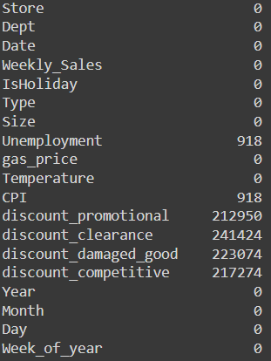

*Figure 28: Missing values per column*

For the Discounts we can assume that the NaN values we days where no discounts were provided to the customers. Hence, it would be safe to impute 0 in place of missing discount values. Since, CPI and Unemployment had had very few missing values(in the same rows) we decided that dropping those rows would be a better option than imputing it with 0 or Median.

A.3. Label Encoding:

The attribute “Type” only cosinsted of 3 values: A, B & C. These were encoded and changed to numerical format as 1, 2 & 3 respectively for prediction purposes.



*Figure 29: Label Encoding of Type_trans column*

A.4. Correlation Matrix & Heatmap:

For feature selection we make use of the correlation heatmap and observe the attribute correlations and decide whether to keep or drop columns

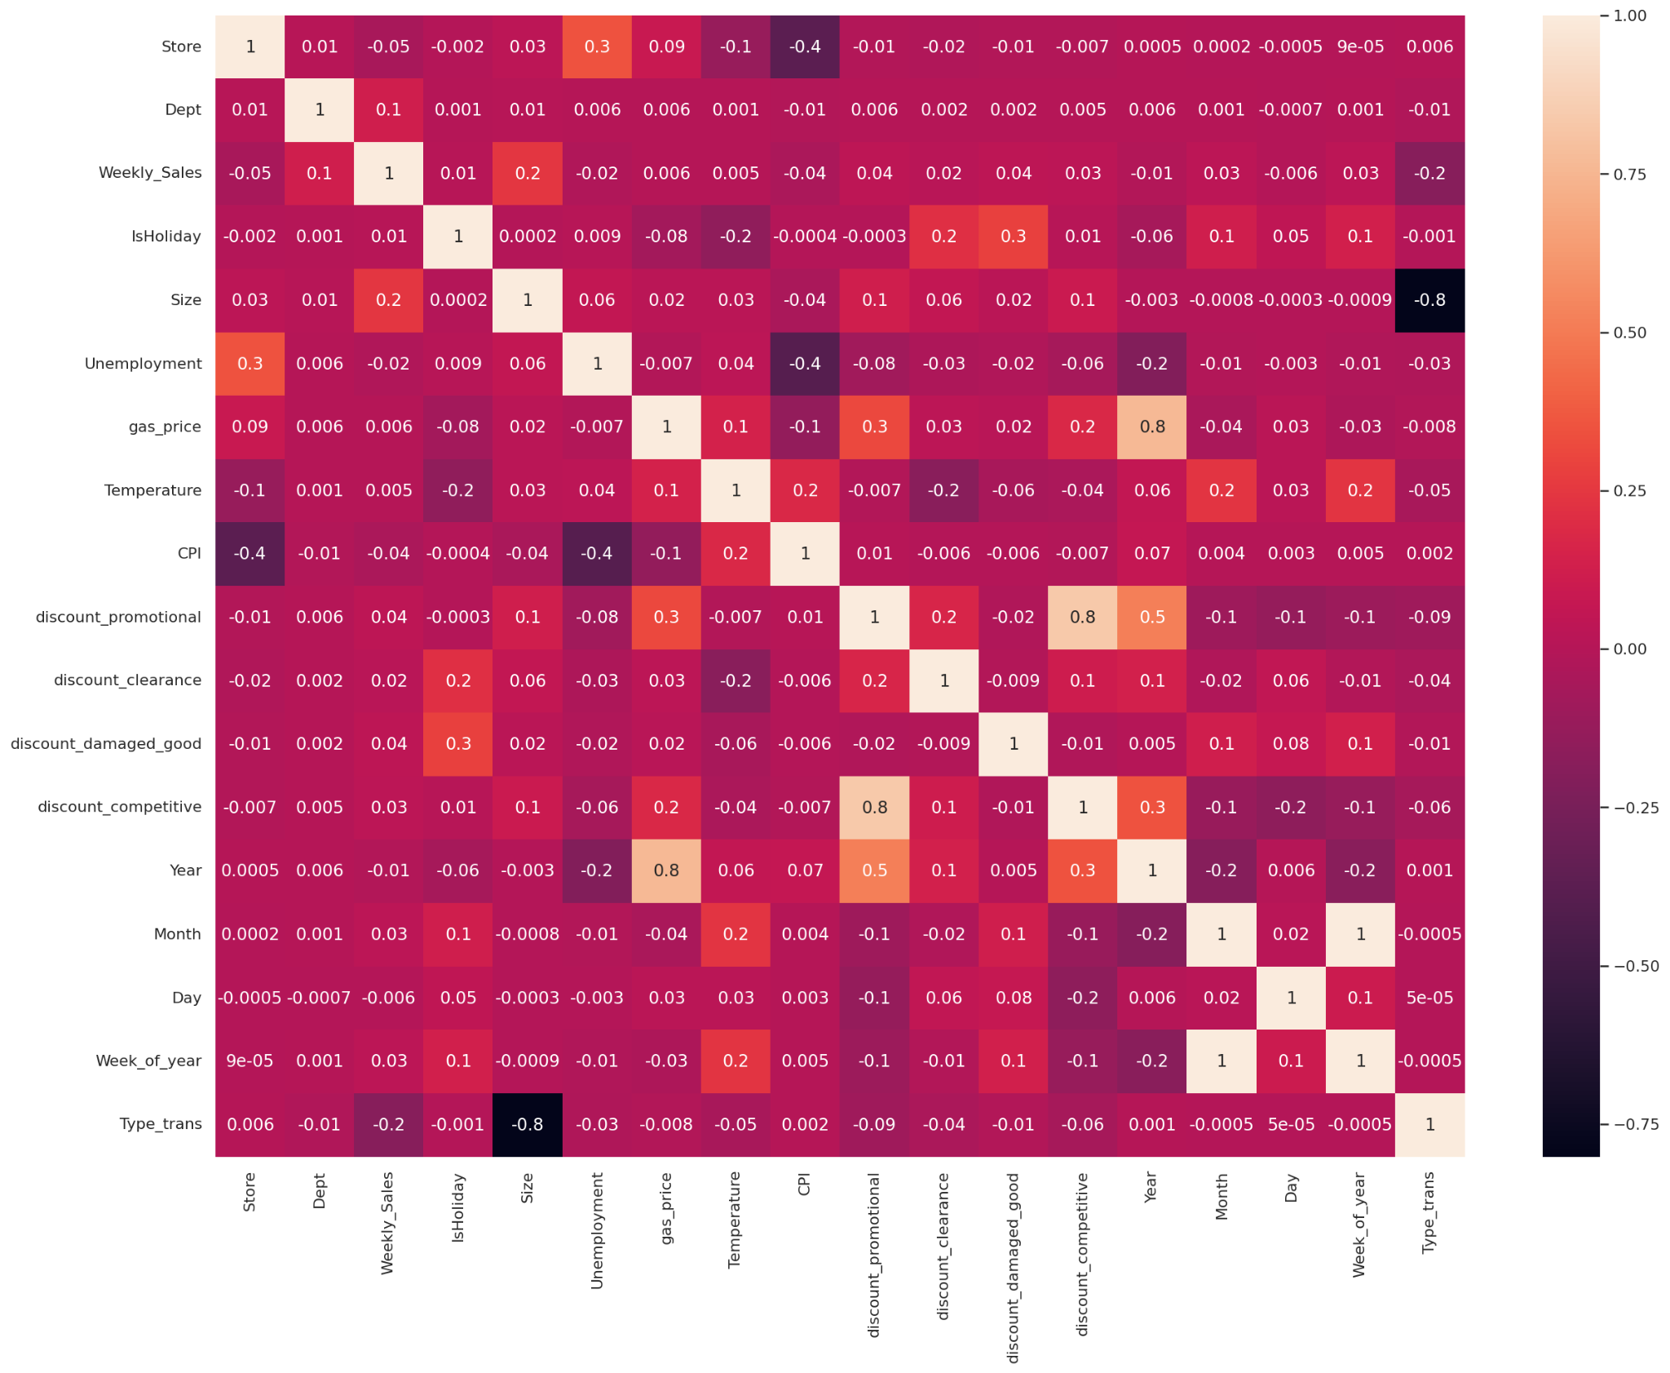

*Figure 30: Correlation Heat map*

We Observe the following:

* Department, Store size and Type have moderate correlation with the weekly sales we can keep these columns
* All the Discounts have very weak correlation with the weekly sales, so can leave these columns out
* Temperature. Fuel price, CPI and Unemployment are very weakly coorelated with the weekly sales, so these columns can also be dropped. However these are external factors and we want to observe how these affect the sales so these have not been dropped for now.
* In sprint 1 we observed sales in the holiday weeks were higher than in the non-holiday weeks so we are keeping it in
* We will drop Month and Day as this information is already contained in the newly created column WeekOfYear

A.5. Scaling & Train Test Splitting:

Since our data consists of columns with widely varying magnitudes, values, or units. We will need to scale these features because ML algorithms, regardless of the unit of measurement, tend to weight greater values higher and consider smaller values as lower values.

We have used MinMaxScaler to perform feature scaling

After dropping the Target: Weekly_Sales column

We have split the dataset into two sets i.e Training set and Testing set. Training set consists of 80% of the dataset and the testing set has 20% of the dataset. The training set would be used to trains the Regression model on the data and Test set will be use to validate the developed model.

1. **Creating ML models to predict Weekly_Sales:**

A set of algorithms were applied on the model to determine the most suitable algorithm for the datasets.

Algorithms Implemented are as follows:

1. Linear Regression
2. Ridge Regression
3. Decision Tree Regression
4. Random FOrset Regression
5. eXtreme Gradient Boosting Regression
6. ARIMA and Auto ARIMA
7. **Model Evaluation & Comparison:**

The RMSE Score was obtained by using Cross Validation Technique so that we can ensure the model does not overfit and give us the wrong results. Additionally, the R-Squared score was calculated to showcase the percentage accuracy of all the Machine learning models. Based on both these score the best performing Model was selected for further analysis.

All the RMSE and R2 Scores for all the Models are as follows:

|  |  |  |  |  |  |
| --- | --- | --- | --- | --- | --- |
| **Sr.No.** | **Algorithm** | **Store 1-10** | **Store 1-10** | **Store 11-35** | **Store 11-35** |
|  |  | RMSE​ | R2 Score | RMSE​ | R2 Score​ |
| 1.​ | Linear regression​ | 23667.78​ | 35.69​ | 21897.43​ | 26.94 |
| 2.​ | Ridge Regression​ | 23667.74​ | 35.69​ | 21897.43​ | 26.94 |
| 3.​ | Decision Tree​ | 5666.13​ | 97.6 | 5188.88​ | 97.67 |
| 4.​ | Random Forest​ | 4486.22​ | 98.12 | 3948.72​ | 98.59 |
| 5.​ | XGBoost​ | 4210.79 | 98.39 | 3712.25 | 98.86 |
| 6 | ARIMA | 21924.35 | 49.7 | 20339.27 | 44.62 |

*Figure 31: Evaluation of various models*

1. **Linear Regression** performed very poorly and has very low R-Squared of 35% for Stores 1-10 and 27% for Stores 11-35 with highest Root Mean Squared Error among all the implemented Algorithms
2. **Ridge Regression** had a very similar performance to Linear Regression with low accuracies and high RMSE across all the stores.
3. **Decision Tree** on the other hand perform exceptionally well with a 97% R2 Score for both the store datasets and RMSE score around 5000.
4. **Random Forest** performed even better than Decision Tree as expected with R2 Score of 98% and with a very low RSME of 4486 and 3948 for Stores 1-10 & Stores 11-35 respectively.
5. **XGBoost** on its own without any hyperparamenter tuning did not perform as well as Random forest. However, after hyperparameter tuning using GridSearchCV XGBoost became the best performing algorithm across all the implemented algorithms with R2 score of 98% and the Lowest RMSE of 4210.79 & 3712.25 for Stores 1-10 & Stores 11-35 respectively.
6. **ARIMA** performed better that Linear and Ridge Regression. However, it failed to surpass any other algorithms. The order (3,0,3) of ARIMA i.e. p,d & q values of ARIMA were determined using autoARIMA. Since these p,d,q values returned the lowest AIC. The RMSE was 21924 & 20339, R2 score was 49% & 44% for Stores 1-10 & Stores 11-35 respectively.

**Evaluating the impact of external variables on the accuracy of the model**

* While building the models we included all these external factors and determined the accuracy
* Lets now drop these external factors and use this new dataset on the best performing model (XGBoost)

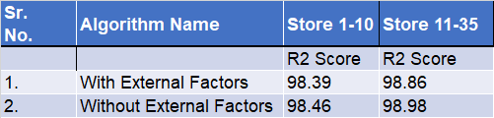

*Figure 32: Impact of external factors*

We observe that after dropping external factors: Temperature, Fuel price, CPI and Unemployment there is a very slight increase in accuracy. This was previously hinted by the correlation matrix where we observed low correlation for all these features. To increase the model efficiency by dropping these rows we save disk space and computing time. Going forward we can drop: Temperature, Fuel price, CPI and Unemployment.

### Multi-label classification problem

In stores.csv, we have a feature “type”, i.e., three types of stores – **A** (Super center), **B** (Discount center), and **C** (Neighborhood markets). Now, based on the given features in the dataset, can we predict the store type? Please consider all the stores for this problem statement. Consider the problem statement as a multi-label classification problem. Use the below classification algorithms and perform hyper-parameter tuning for the Deep Learning models.

#### Ensemble models

The goal of the ensemble methodology is to use solutions generated by different models to an original problem and get a better composite global model. This method helps in ensuring accurate and reliable performance metrics based on which decisions and estimates can be deduced [1]. There are several methods to implement ensemble models. Some basic methods are average, weighted average and voting. We have implemented all three of these and explained in the following sections. Some of the advanced techniques are stacking, bagging, boosting, etc. Out of these we have implemented stacking method.

As we need multiple models for ensembling, we have chosen the following three classification models.

* K-Nearest Neighbors

|  |
| --- |
| knn = KNeighborsClassifier(3)    *Figure 33: ROC curve of KNN* |

*Figure 34: Performance metrics of KNN*

* Support vector classifier

|  |
| --- |
| svc = SVC(gamma=2, C=1) |

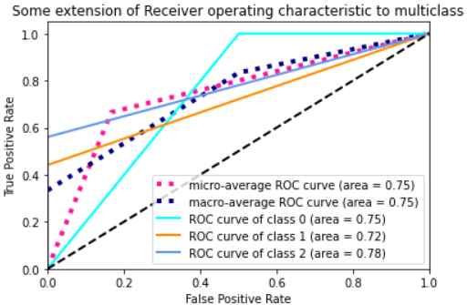

*Figure 35: ROC Curve of SVC*

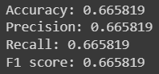

*Figure 36: Performance metrics of SVC*

* Multi-Layer Perceptron

|  |
| --- |
| mlp = MLPClassifier(alpha=1, max_iter=1000)    *Figure 36: ROC Curve of MLP*    *Figure 37: Performance metrics of MLP* |

Analyze the dataset for CECS551_dataset_02 1

Correlation histogram of the features 1

Correlation Matrix heatmap 1

Feature Importance 1

Visualizing Weekly and Monthly sales patterns for the top 35% of the department sales 1

Investigate the relationship between weekly sales over CPI and unemployment for the first 10 stores. 1

Investigate the impact of various types of discounts on the overall sales 1

2.1.2 Analyze the dataset for CECS551_dataset_02 1

Sprint 2 1

Colab URLs: 1

CECS551 Dataset 01 Problem Statement: 1

1. Design a prediction model to forecast the weekly sales across first ten stores. 1

2. Multi-label classification problem 1

a. Ensemble models 1

I. Average 1

II. Weighted Average 1

III. Voting 1

IV. Stacking 1

b. Recurrent Neural Network 1

c. Convolutional Neural Network (CNN) 1

CECS551 Dataset 02 Problem Statement: 1

Sprint 3 1

We analyze the graph for each class: 1

References 1

##### I. Average

In this method, multiple models are built independently. Later, predictions of each model are used to calculate the average of all the predictions. This method is generally used for regression problems [2].

|  |
| --- |
| pred_1 = knn.predict(X_test) pred_2 = svc.predict(X_test) pred_3 = mlp.predict(X_test) # final prediction after averaging on the prediction of all 3 models pred_final = (pred_1+pred_2+pred_3)/3.0 |

Mean squared error between real values and the predicted values is 0.0784

##### II. Weighted Average

This method is an extension of the previous one. Only difference is, instead of calculating the average, the weighted average is calculated. Every model is assigned a weight as per importance of the prediction made by that model [2].

|  |
| --- |
| pred_1 = knn.predict(X_test) pred_2 = svc.predict(X_test) pred_3 = mlp.predict(X_test) # final prediction after averaging on the prediction of all 3 models pred_final = (pred_1*0.3+pred_2*0.3+pred_3*0.4) |

Mean squared error between real values and the predicted values is 0.0828

##### III. Voting

This method also uses outputs of multiple independent models. Prediction made by every model is considered as a vote. A class with maximum votes is returned as final prediction of the ensemble model [2].

|  |
| --- |
| from sklearn.ensemble import VotingClassifier  model = VotingClassifier(estimators=[('knn', knn), ('svm_rbf', svc), ('mlp', svc)], voting='hard') model.fit(X_train,y_train) |

Mean accuracy made by this ensemble model is 0.6923

##### IV. Stacking

Stacking is a technique used to achieve highest generalization accuracy [1]. This technique is based on generating a meta learner which in turn is used to predict the final results.



*Figure 38: Visual representation of stacking*

As we can see from the above illustration, model stacking is quite literally stacking multiple models. Several models can be combined into a meta learner by using a baseline classifier. Each of the classification models that we are using will be making their own predictions and these will act as an input to our meta learner. The prediction probabilities of individual models are combined and fed to the meta learner.

After fitting all three models, we are using logistic regression as our baseline classifier to combine these three models to create a meta learner using the stacking technique.

|  |
| --- |
| # Define estimators estimator_list = [  ('knn',knn),  ('svc',svc),  ('mlp',mlp) ]  # Build stack model stack_model = StackingClassifier(  estimators=estimator_list, final_estimator=LogisticRegression() ) |

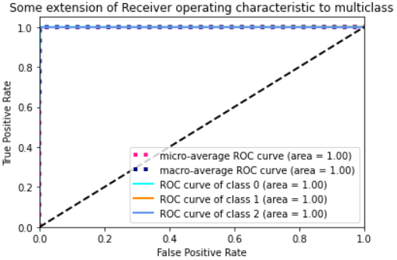

*Figure 39: ROC curve of stacked model*

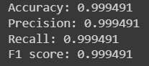

*Figure 40: Performance metrics of stacked model*

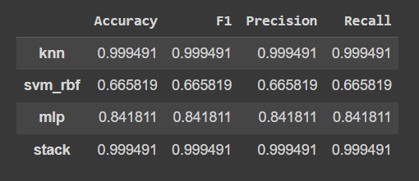

*Figure 41: Comparing metrics of various models*

This table compares performance metrics of 3 different classifiers and the meta learner (stack). As we can observe, the combined model gives better performance than the individual models. Since our dataset is small, we are seeing knn is giving the same accuracy. This technique can prove to be more effective in the case of a bigger dataset.

#### Recurrent Neural Network

Predicting the store type by considering the data of the first ten stores by using a LSTM Recurrent Neural Network. We used the LTSM Sequential model to train a neural network to predict the store type (A, B and C) and considered the data of all available stores ie 1-35.

* Performing Hyper Parameter Tuning on the Sequential model.

1. As a part of hyper parameter tuning, we checked with the number of units in a layer, number of epochs, number of hidden layers and the dropout value.
2. We used sparse_categorical_crossentropy loss function in all the iterations.
3. We picked the parameters that gave us the most optimal results.

Note: As this is a multi-label classification problem with 3 labels, we could not use a binary loss function. Also, due to the same reason, we used micro-average ROC curve area and macro-average ROC curve area to plot the ROC curves.

1. RNN with 1 input layer, 3 hidden layers with 14 units with a dropout value of 0.2 and an output layer with 3 units. For fitting the model, epochs = 50

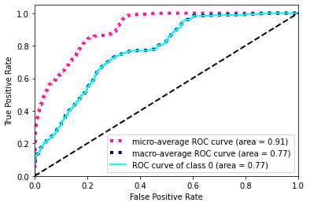

*Figure 42: ROC Curve of the first model*

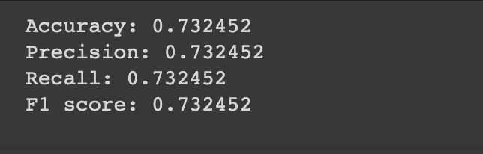

*Figure 43: Performance metrics of the first model*

1. For the second trail, we made an RNN model with 1 input layer, 2 hidden layers with 45 units each, a dropout value of 0.2 and number of epochs = 50.

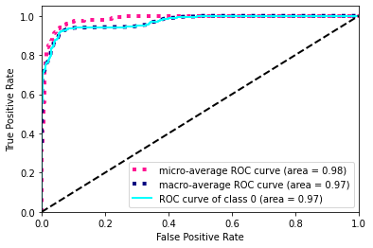

*Figure 44: ROC Curve of second model*

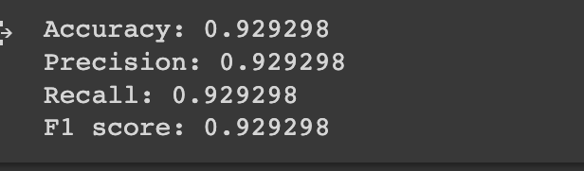

*Figure 45: Performance metrics of second model*

Accuracy, Precision, Recall and F1 Score (Second model)

As we can see, increasing the number of units in all the layers from 14 to 45 increased the accuracy drastically. So, we will be going forward with units = 45.

1. For the third trail, we increased the number of epochs to 100 and remaining parameters are the same as model2.

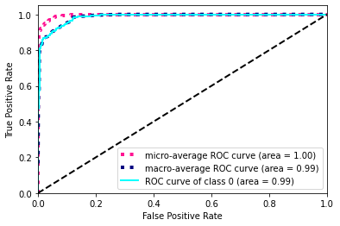

*Figure 46: ROC Curve of third model*

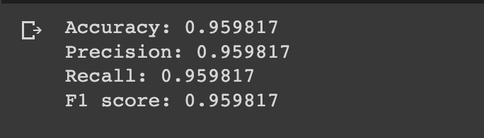

*Figure 47: Performance metrics of third model*

Accuracy, Precision, Recall and F1 Score (Third model)

1. In the third model, increasing the epochs from 50 to 100 improved the model efficiency. So, we increased the epochs to 150 in the fourth trail. We tried this with 2 variations:
   1. Units = 45, epochs = 150, 3 hidden layers with a dropout value of 0.2
   2. Units = 45, epochs = 150, 2 hidden layers with a dropout value of 0.4

The second variation gave us perfect scores and thus we went ahead with the same.

Final parameter values:

* Epochs: 150
* Input layer Units: 45
* Hidden layer units: 45
* Output layer units: 3
* Number of Hidden layers : 2
* Dropout value: 0.4
* Batch size: 128
* Loss function: sparse_categorical_crossentropy

1. Final RNN model

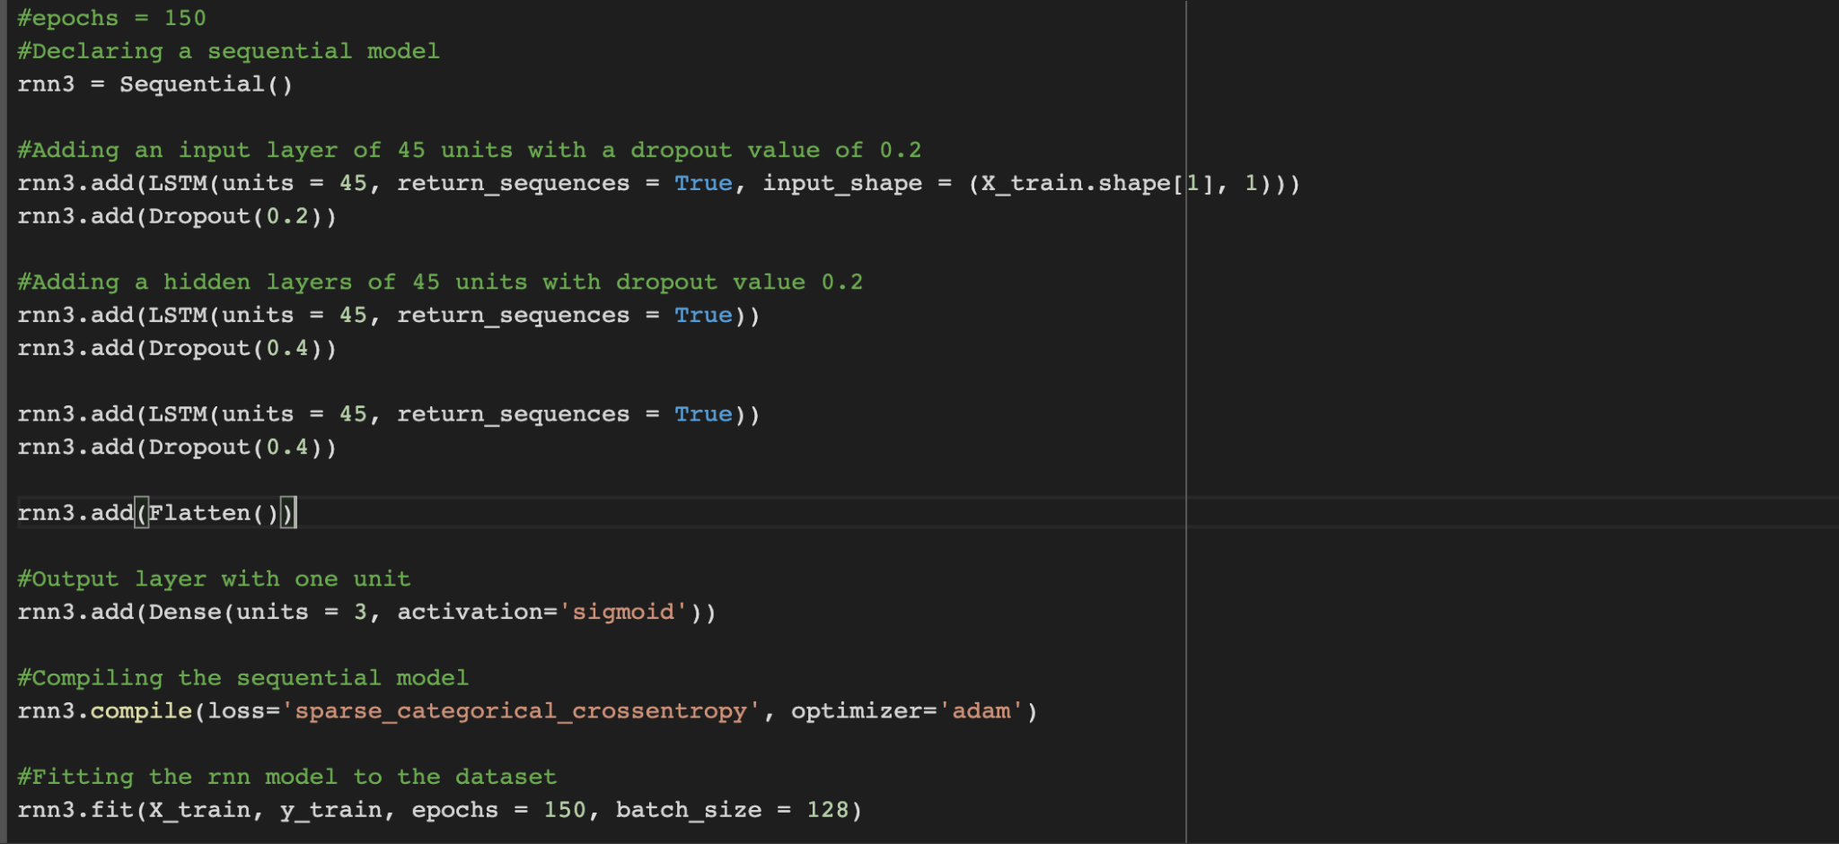

*Figure 48: Final RNN Model*

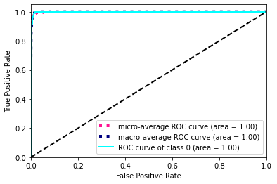

*Figure 49: ROC Curve of final model*

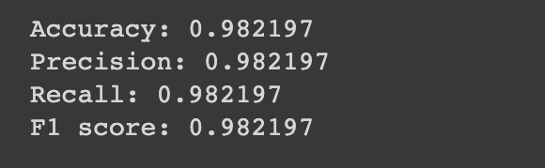

*Figure 50: Performance metrics of final model*

Thus, after a lot of optimization and hyper parameter tuning, our resultant Recurrent Neural Network achieved an accuracy of 0.982197.

#### c. Convolutional Neural Network (CNN)

Generally, CNN is applied on image classification where the data is in the form of 2 dimensional matrix. However, in our case the data does not contain images. As our data is 1 dimensional, we chose to use conv1d from Keras.

We implemented CNN with

1. 3 convolutional layers
2. Activation function ReLu with alpha value 0.001
3. Maxpooling with pool size 3
4. Activation layer SOFTMAX
5. Flattening

We tuned the model based on following hyperparameters:

**Optimizer algorithm**: Adam (Adaptive Moment Estimation)

**Epochs**: 100

**Loss function**: sparse categorical crossentropy

**Dropout rate**: 0.5

**Batch size**: 32

**Pool Size**: 2

1. The following graphs shows ROC score for all three labels when the **optimizer** was **RMSProp** along with parameters mentioned as above

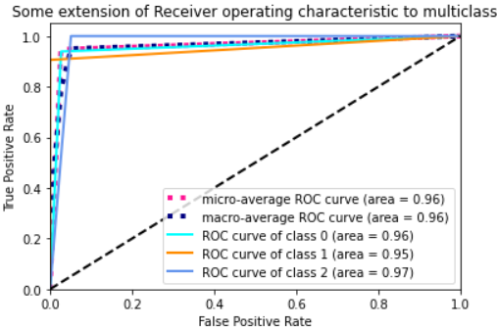

*Figure 51: ROC of first model*  
  
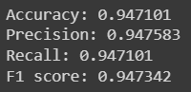

*Figure 52: Performance metrics of first model*

1. The following graphs shows ROC score for all three labels when the **optimizer** was **Nadam** along with parameters mentioned as above

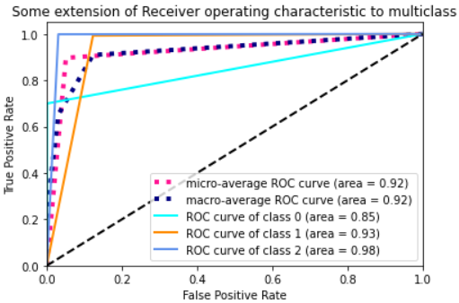

*Figure 53: ROC Curve of second model*

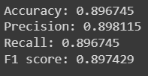

*Figure 54: Performance metrics of second model*

1. The following graphs shows ROC score for all three labels when the **optimizer** was **Adam** along with parameters mentioned as above with batch size 32  
     
   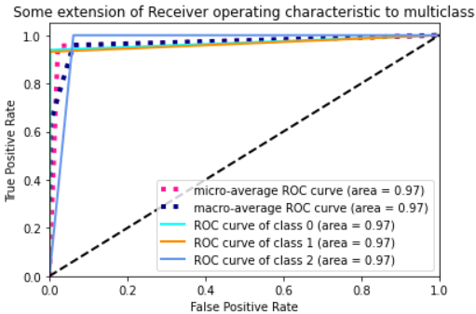

*Figure 55: ROC Curve of third model*

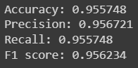

*Figure 56: Performance metrics of third model*

1. As we can see so far optimizer Adam has given the highest accuracy, we tried **different batch sizes** to increase it. Following plots show ROC score for different batch sizes

**Batchsize = 16**

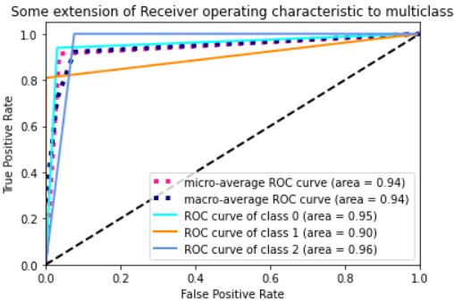

*Figure 57: ROC Curve of fourth model*

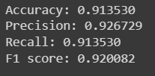  
*Figure 58: ROC Curve of fourth model*   
  
**Batch size 64**  
  
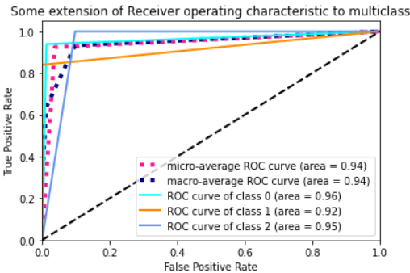

*Figure 59: ROC Curve with batch size = 64*

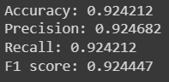

*Figure 60: Performance metrics with batch size = 64*

1. As we can see batch size 32 gives the highest accuracy, we tried to tune **dropout rate** by making it **0.4**

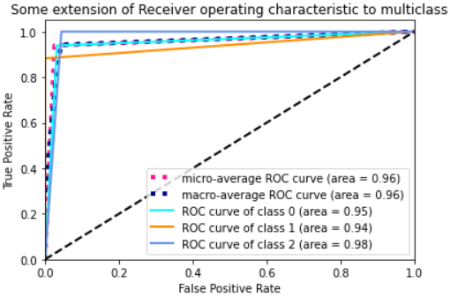  
*Figure 61: ROC Curve of fifth model*   
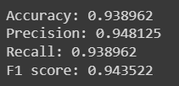

*Figure 62: Performance metrics of fifth model*

Dropout **rate 0.5 is giving higher accuracy** which is why we chose the same for the final model.

1. We further tuned the **pool size** to **2** and got ROC score and accuracy as shown below:

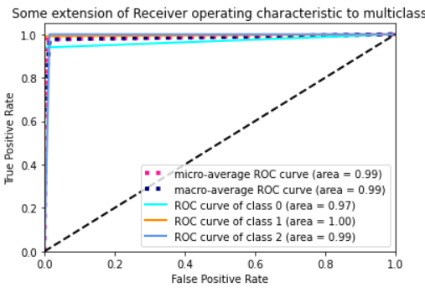

*Figure 63: ROC Curve of sixth model*   
  
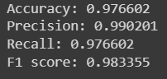  
*Figure 64: Performance metrics of sixth model*

1. We also tried increasing the number of epochs to 200 to increase the accuracy. As we can see in the plot, ROC score and performance metrics are slightly better for 100 epochs.  
   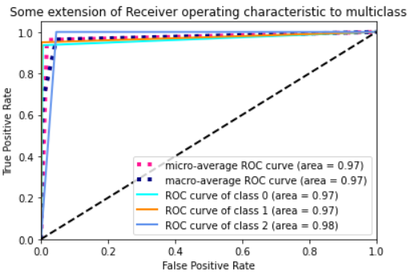

*Figure 65: ROC Curve of seventh model*  
  
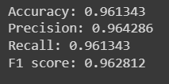

*Figure 66: Performance metrics of seventh model*

Final CNN Model :

|  |
| --- |
| # Create sequential model  cnn_model = tf.keras.models.Sequential() #First CNN layer with 32 filters, conv window 3, relu activation and same padding cnn_model.add(Conv1D(filters=32, kernel_size=(3,), padding='same', activation=tf.keras.layers.LeakyReLU(alpha=0.001), input_shape = (X_train.shape[1],1))) #Second CNN layer with 64 filters, conv window 3, relu activation and same padding cnn_model.add(Conv1D(filters=64, kernel_size=(3,), padding='same', activation=tf.keras.layers.LeakyReLU(alpha=0.001))) #Third CNN layer with 128 filters, conv window 3, relu activation and same padding cnn_model.add(Conv1D(filters=128, kernel_size=(3,), padding='same', activation=tf.keras.layers.LeakyReLU(alpha=0.001))) #Fourth CNN layer with Max pooling cnn_model.add(MaxPool1D(pool_size=(2,), strides=2, padding='same')) cnn_model.add(Dropout(0.5)) #Flatten the output cnn_model.add(Flatten()) #Add a dense layer with 256 neurons cnn_model.add(Dense(units = 256, activation=tf.keras.layers.LeakyReLU(alpha=0.001))) #Add a dense layer with 512 neurons cnn_model.add(Dense(units = 512, activation=tf.keras.layers.LeakyReLU(alpha=0.001))) #Softmax as last layer with outputs cnn_model.add(Dense(units = 3, activation='softmax')) cnn_model.compile(optimizer='adam', loss = 'sparse_categorical_crossentropy', metrics=['accuracy']) cnn_model_history = cnn_model.fit(X_train, y_train, epochs = 100, batch_size = 32) |

## CECS551 Dataset 02 Problem Statement:

**Task 1:** Design a machine learning model to make accurate predictions for product sales for next 10 days in advance (the data set includes daily unit sales per product) and compare the performance of different machine learning algorithms.

1. **Perform data preprocessing and exploratory data analysis**

A.1 Downcasting:

Downcast in simple terms means converting high storage consuming

datatype to satisfying low storage consuming datatype.Reduced the data

frame size without altering the values.

<https://pypi.org/project/pandas-downcast/> API Reference

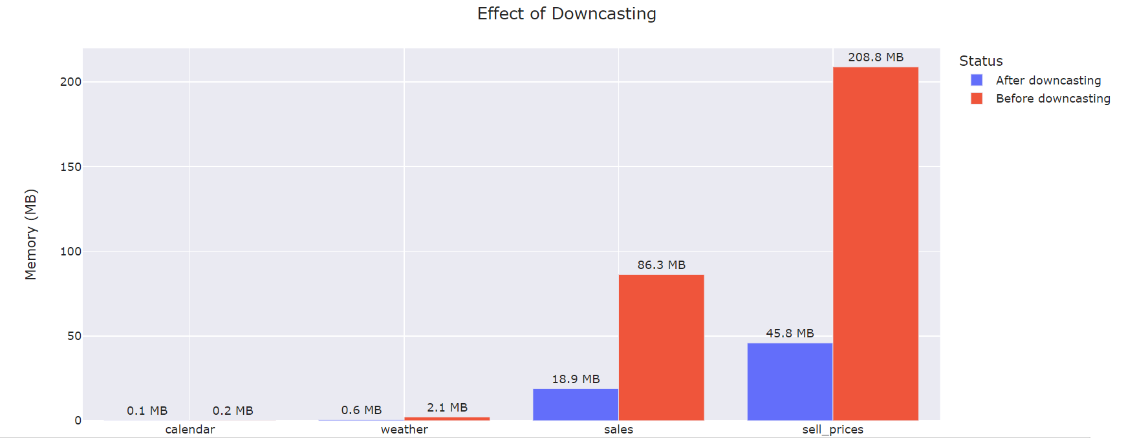

*Figure 67: Down casting the dataset*

A.2 Melting the data:

Sales data is horizontally huge and each day sales are in columns. But Prices data has day sales in records. So, we need to cut down the horizontal table into set of records for each day into vertical table. It is also called as **melting the data**.

API Reference - <https://pandas.pydata.org/docs/reference/api/pandas.melt.html>

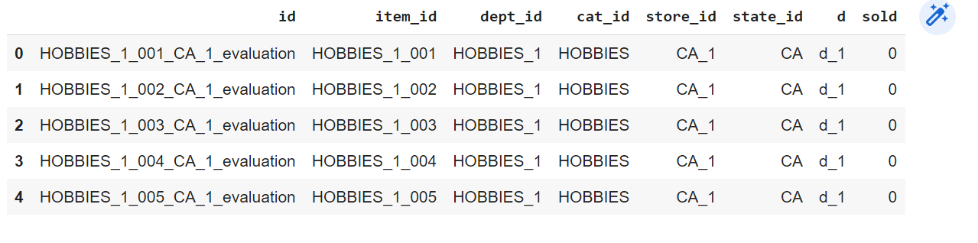

*Figure 68: Melting data*

A.3 Processing the data:

Joining Sales table with Calendar table (LEFT JOIN) with respect to Day column (since we have melted days columns to single one), Similarly Let’s join the result with price data, based on store_id, item_id and week string. Using Left join. Below picture shows data after joining.

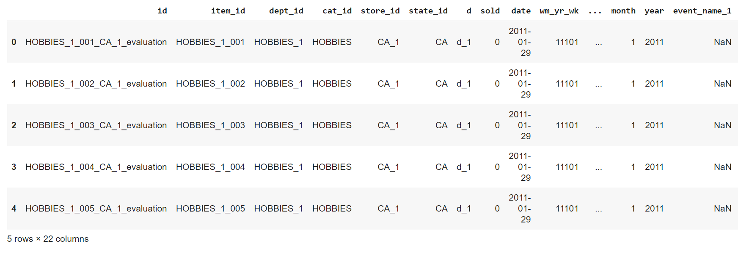

*Figure 69: Merging all the required data*

A.4 Checking for null values:

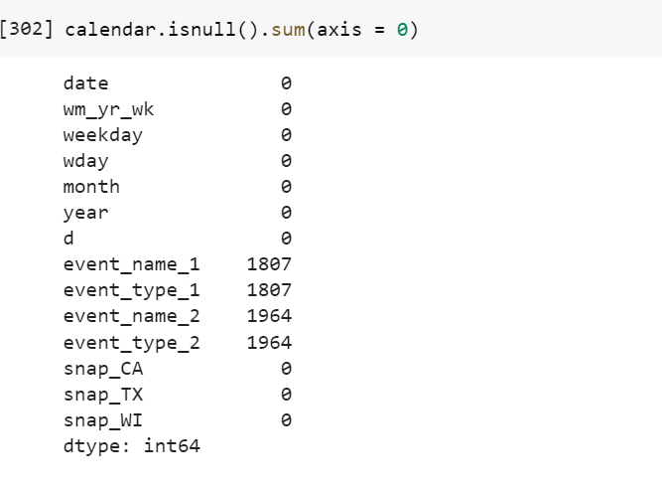

*Figure 70: Null values per column*

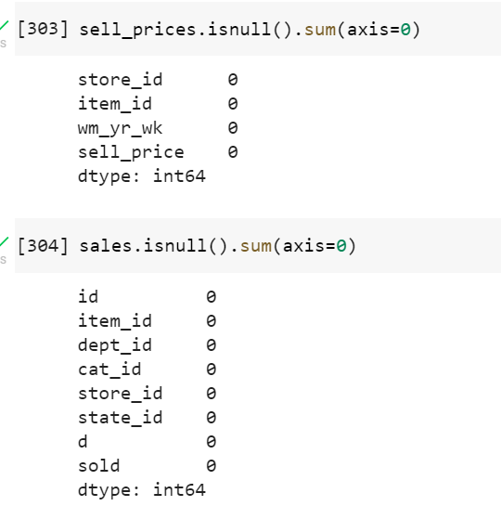

*Figure 71: After handling null values*

A.5 Data Observations:

We have plotted to understand the distributions of data with different features to understand the data.

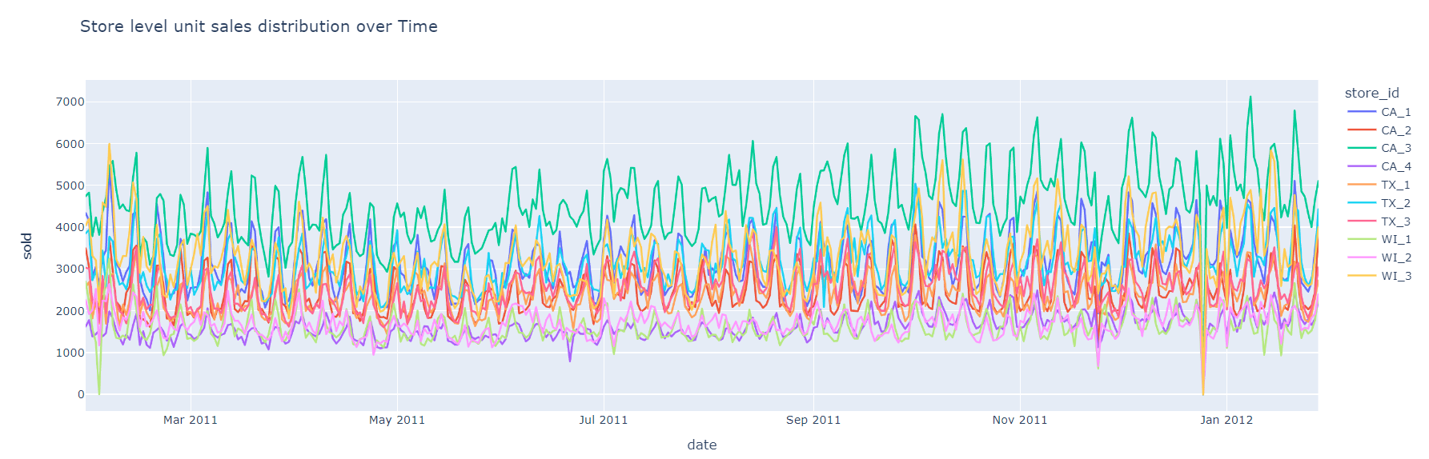

*Figure 72: Data Distribution with various features*

We have created subplots to identify the individual store level sales over the entire series in the data, Overall CA3 has the highest number of sales over time series (365 days) and there are patterns of sales in all stores.

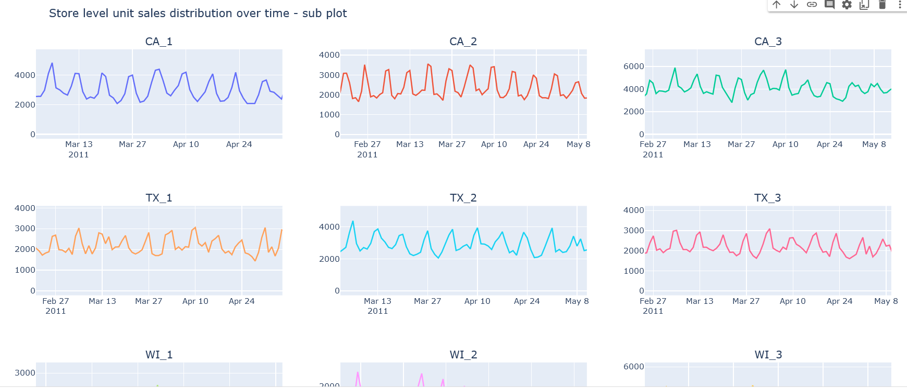

*Figure 73: Store level unit sale distribution for 365 days of data magnified to Mar 2011 – May 2011*

All stores are following specific weekly pattern of sales and the graph dips on Christmas Day (Dec 25, 2011) for all stores. This might be because stores being closed during Christmas. Most of the store ***unit sales dropped below 10 during the Christmas day.***

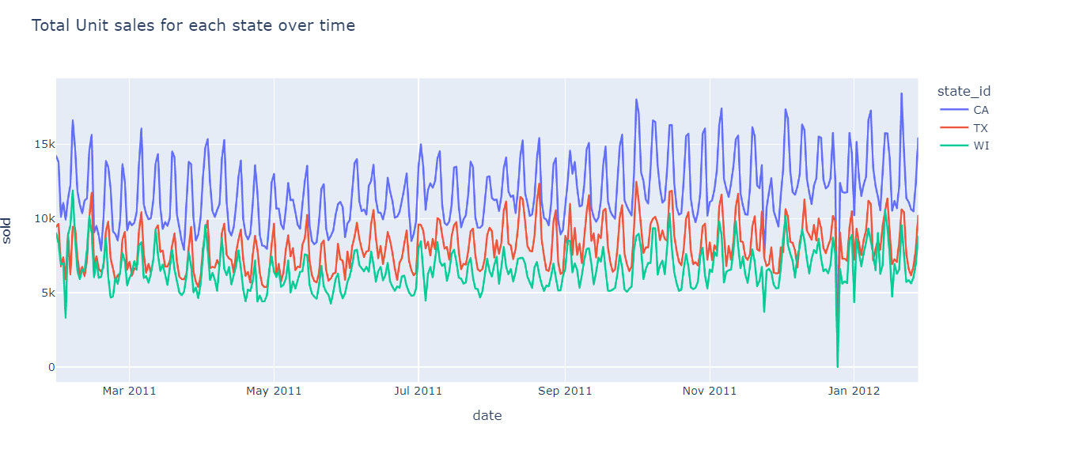

*Figure 74: Total units sold for each state over the specified duration*

California sells a greater number of products on daily basis, the number of products sold daily were more for TX as compared to WI and for both the states seems to fall in the same trend as we can see from the graph that they got overlapped.

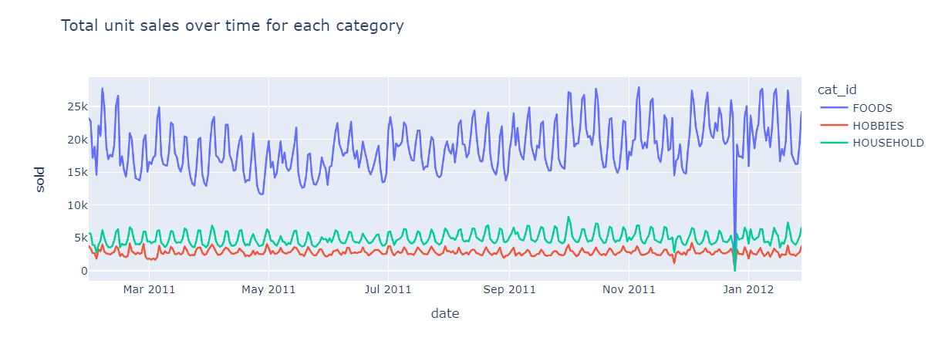

*Figure 75: Total number of units sales over the duration per category*

Foods is most sold items in the category and hobbies is the least. The graph of hobbies and household doesn’t follow any trend.

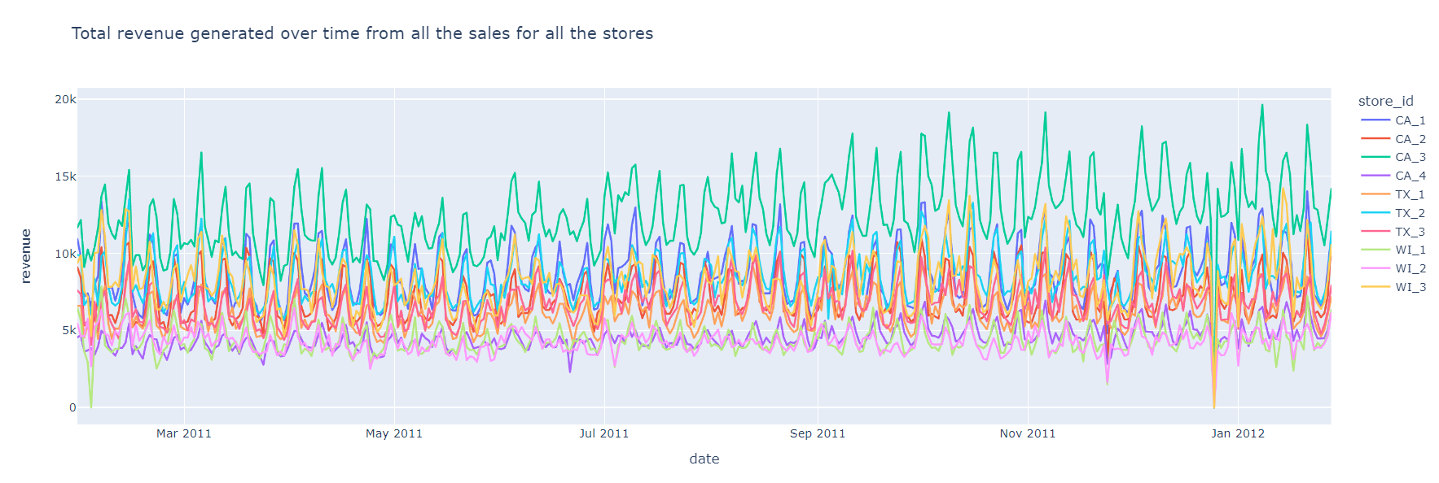

*Figure 76: Total Revenue generated over the specified duration*

CA_3 got the highest revenue in the month of January in 2012, where WI_1 got the least revenue for the given duration.

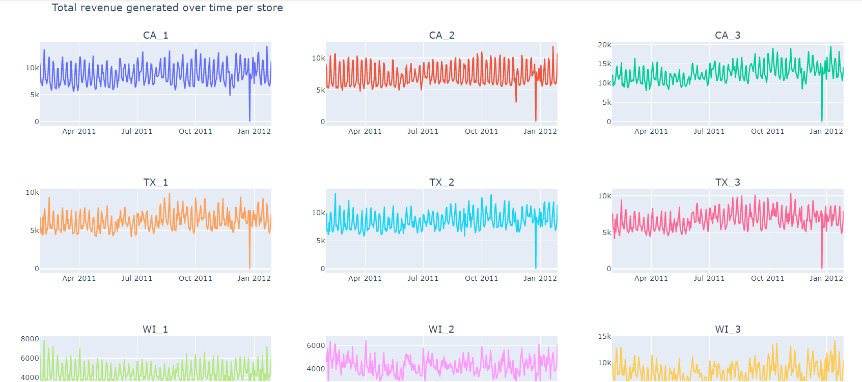

*Figure 77: Total revenue generated per store*

For every store on 25th of Dec 2011 and starting of Jan graphs there was a steep in the graph.

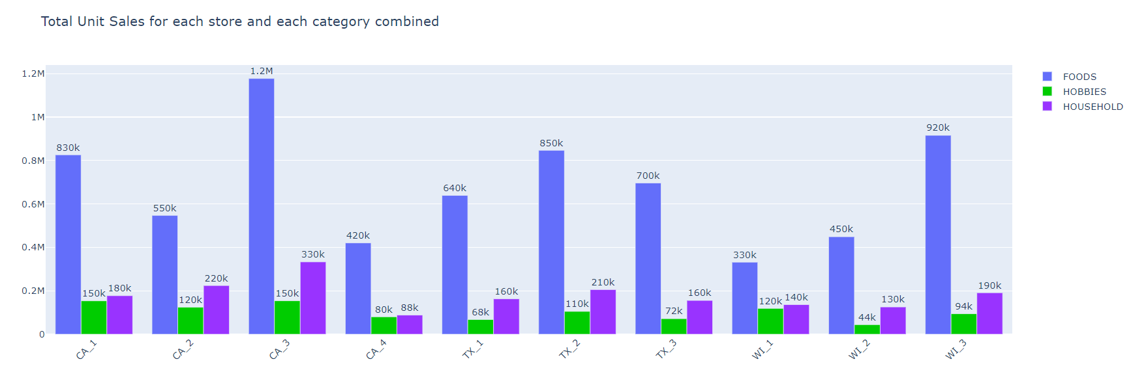

*Figure 78: Total unit sales per store and per category*

CA_3 sold the most FOODS and HOUSEHOLD category items. CA_3 sold HOBBIES category items more than CA_1 but the difference is very less. The difference in number of items sold in HOBBIES category across all the stores is very less as compared to FOODS and HOUSEHOLD categories.

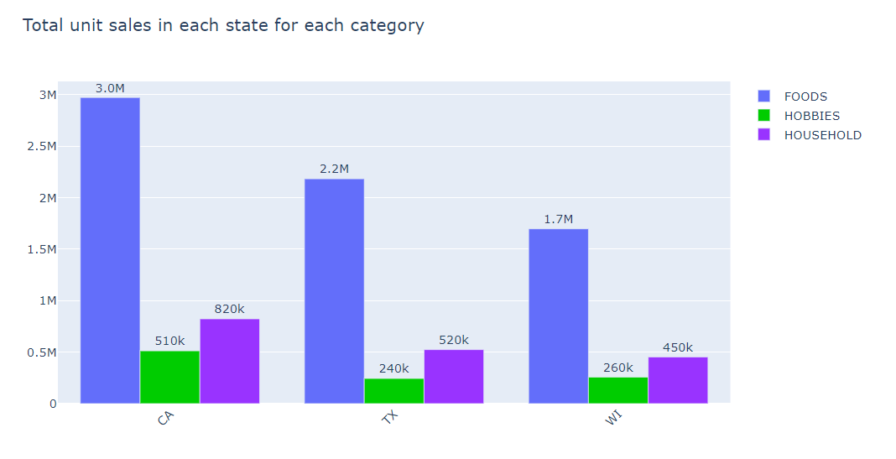

*Figure 79: Total unit per state per category*

CA sold most items in all the categories. CA sold almost double the items in HOBBIES category as compared to TX and WI, TX and WI sold almost the same number of items in FOODS category, TX sold more items than WI in HOUSEHOLD category.

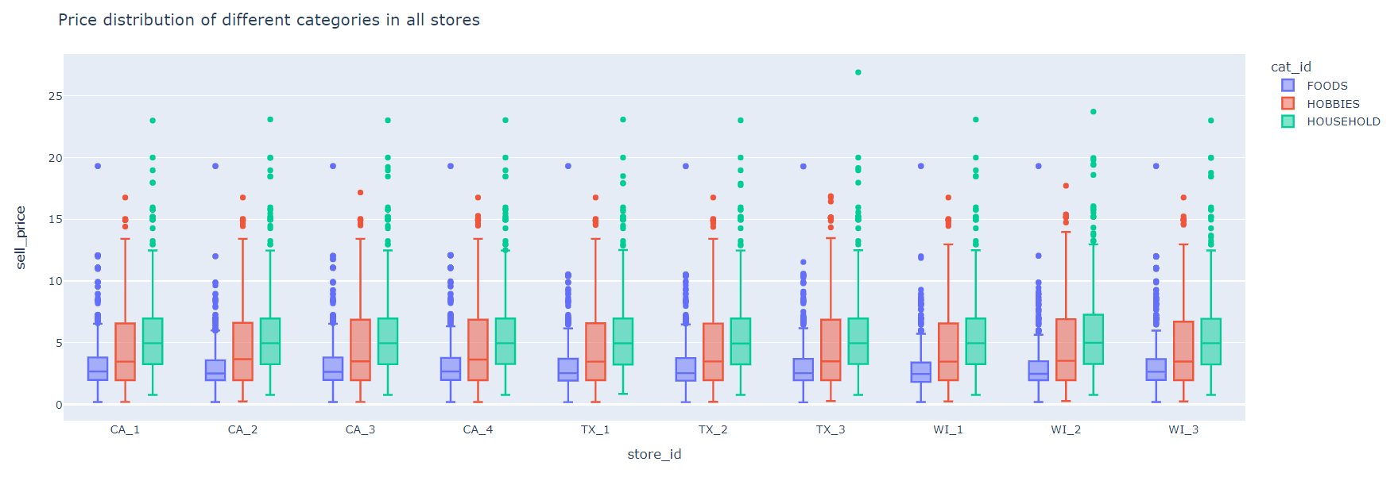

*Figure 80: Price distribution of all the categories*

HOBBIES category items have the largest price range, FOODS category items have the least price range, The median price for HOUSEHOLD category is more as compared to FOODS and HOBBIES.

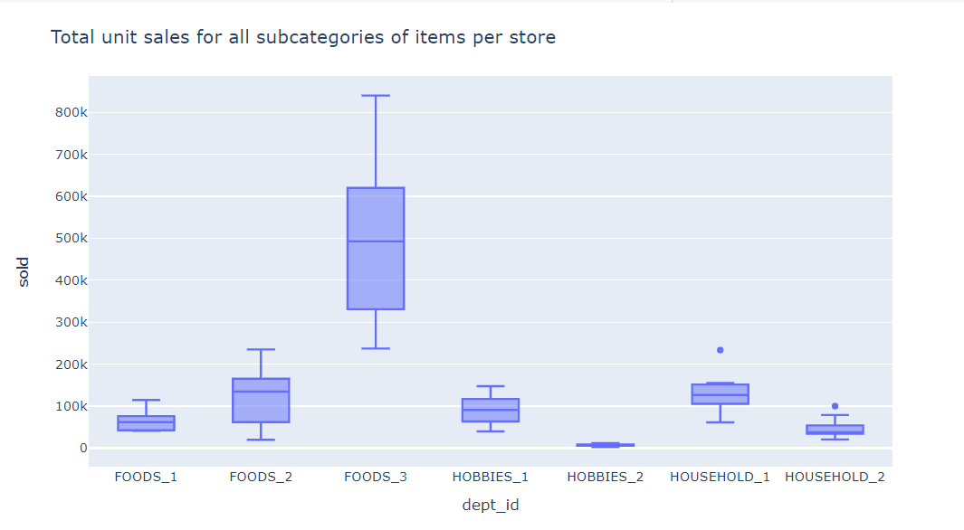

*Figure 81: Total unit sales per subcategory per store*

FOODS_3 category has the most sold items among all the stores, FOODS_3 have the largest range for the number of items sold in different stores. It also has the highest variance in sales, HOBBIES_2 category have the least sold items among all the stores. It also has the least variance in sales.

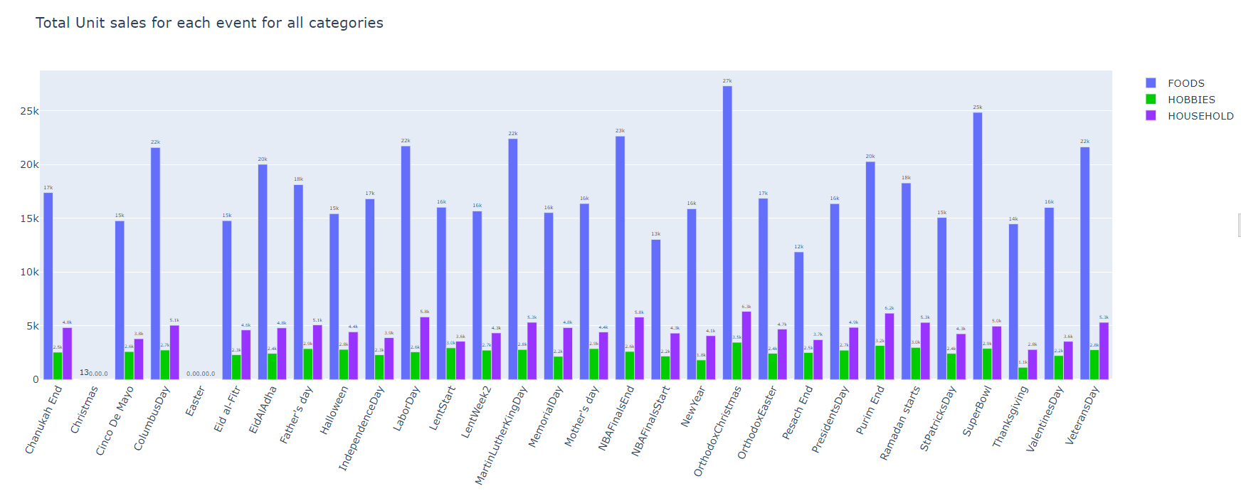

*Figure 82: Total unit sales per event*

Highest unit sales are for food on Orthodox Christmas and lowest units sold was on Christmas and easter for all categories.

SNAP: In the United States, the Supplemental Nutrition Assistance Program, formerly known as the Food Stamp Program, is a federal program that provides food-purchasing assistance for low- and no-income people.

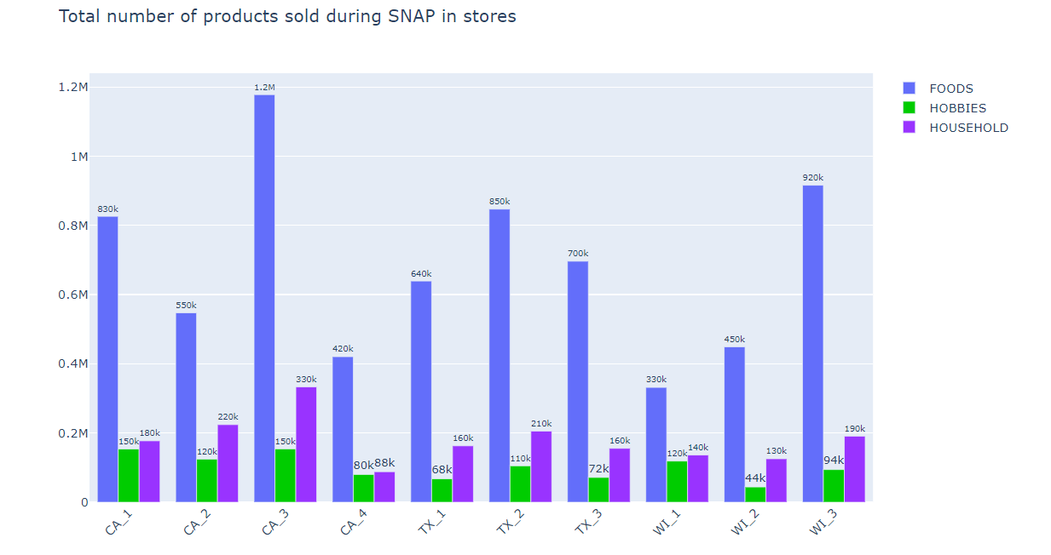

*Figure 83: Total number of products sold during SNAP*

CA_3 sold the most number of items in every category among all the stores during SNAP, CA_4 sold least number of FOODS category items during SNAP, WI_2 and WI_3 sold almost same number of FOODS category items during SNAP.

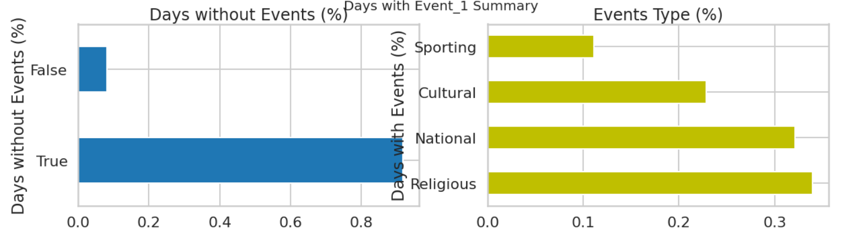

*Figure 84: Events summary*

Events type distribution across the calendar date, a greater number of event types are religious and the lowest was sporting.

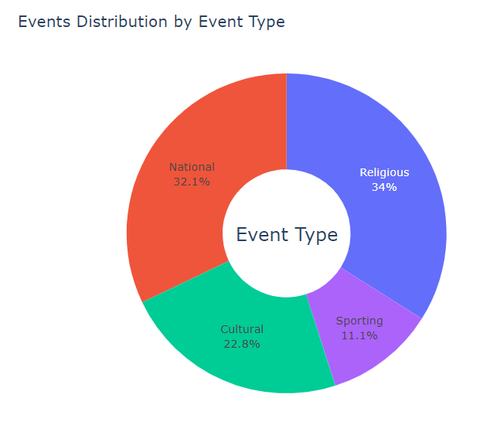

*Figure 85: Event distribution by type*

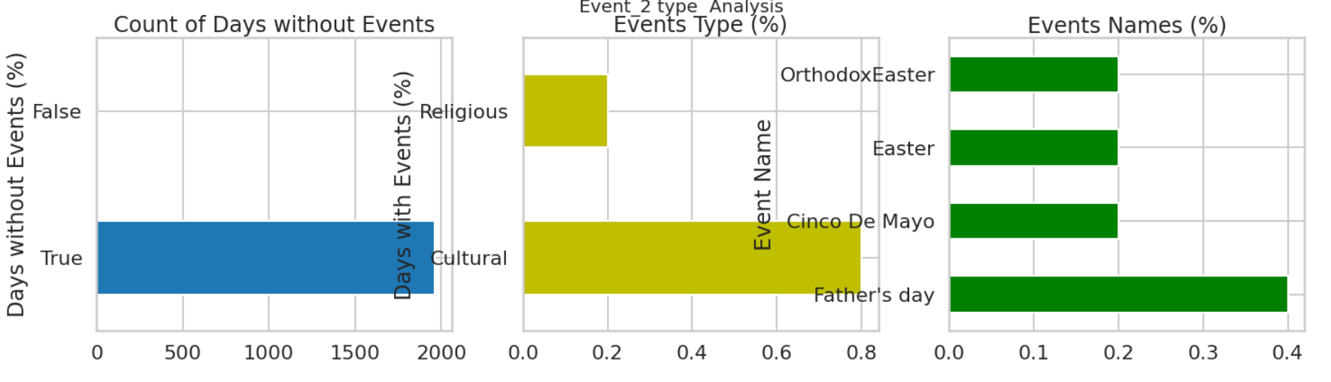

*Figure 86: Event distribution*

While comparing all the 3 plots, Father’s Day got more percentage while Easter, Cinco De mayo, and Orthodox easter remains constant

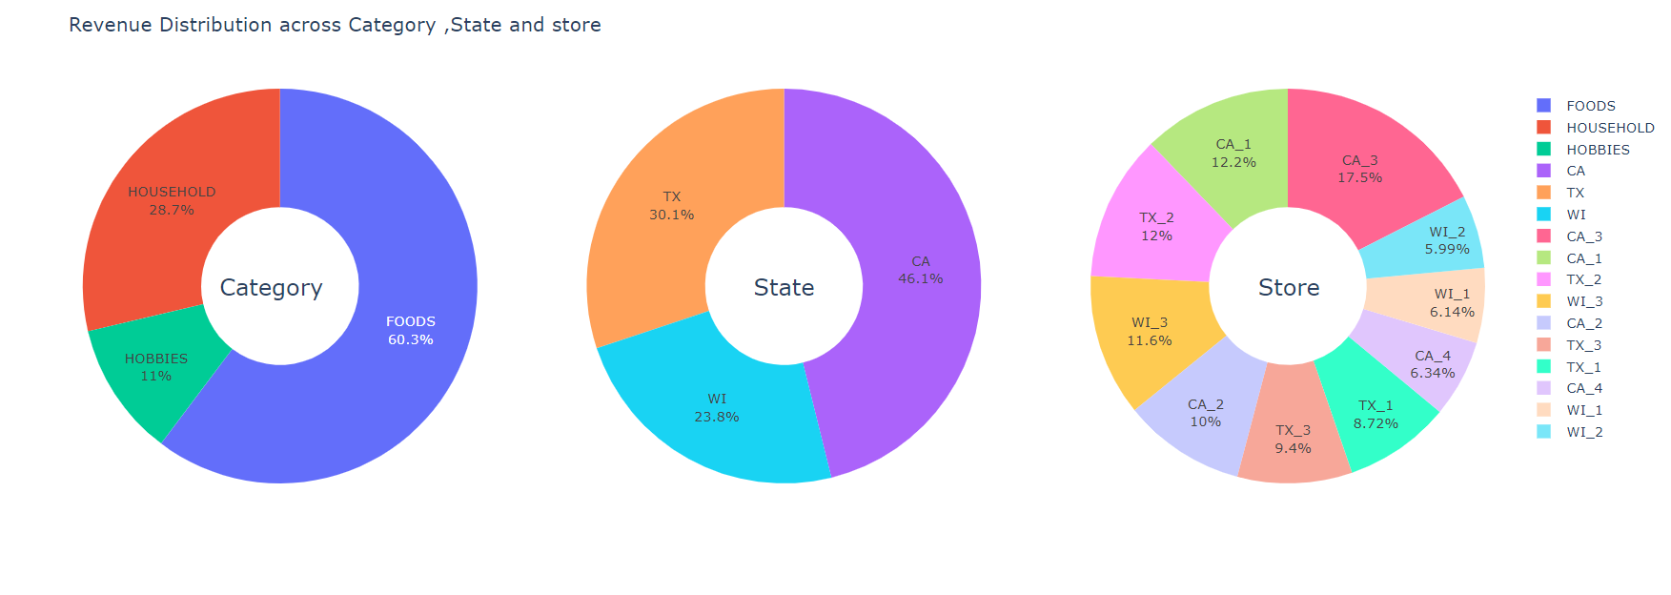

*Figure 87: Visualized revenue distribution*

Revenue distribution across category, state and store in percentages.

**Does seasonality and trend exist in the dataset?**

**The dip is on the day of Christmas where the only day the store is closed**

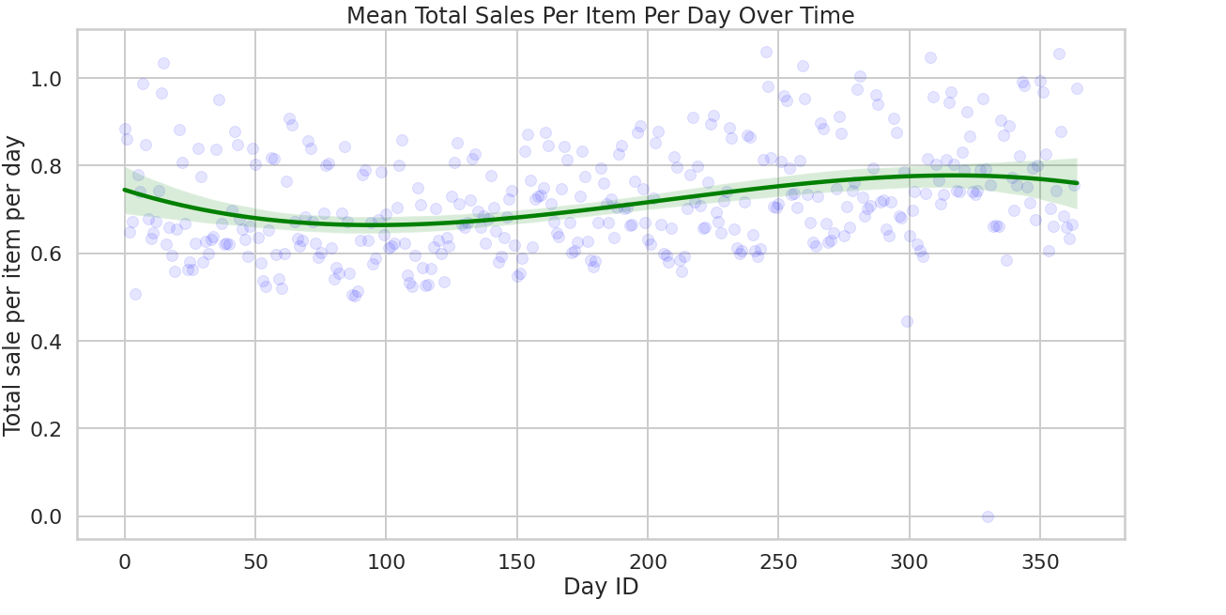

*Figure 88: Total sales per day over time*

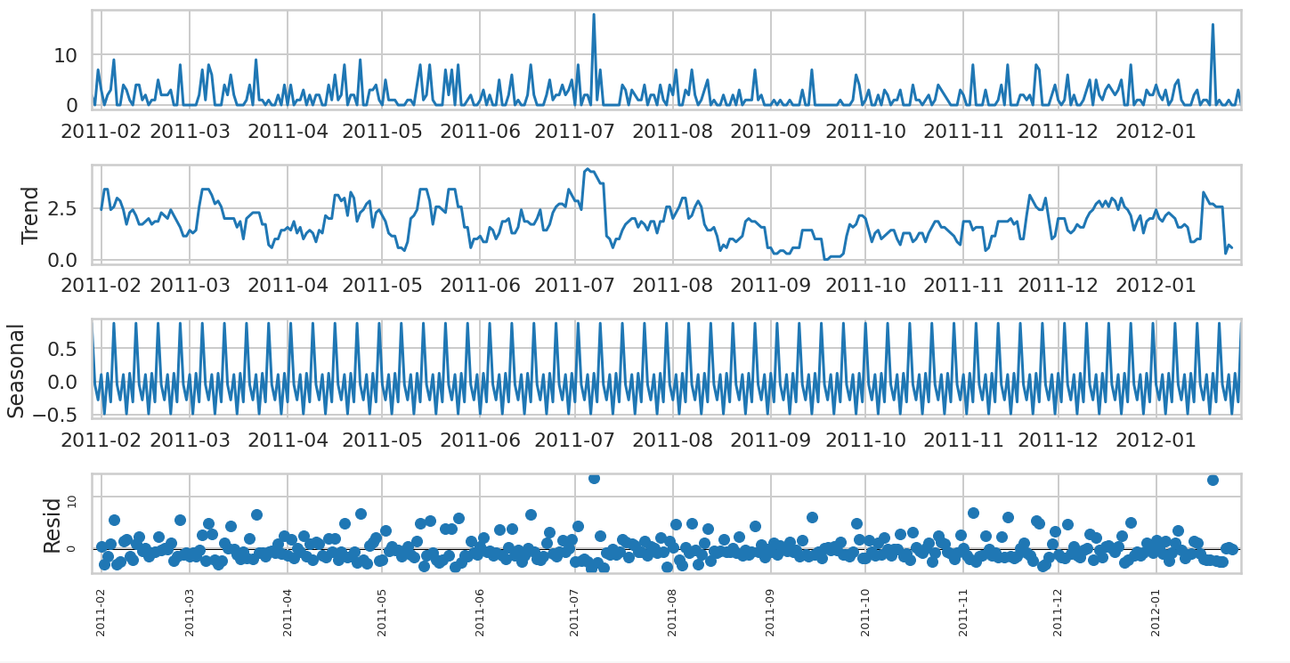

*Figure 89: Seasonality Decomposition*

Seasonality Decomposition: The seasonal decomposition shows how much a time series shows seasonality and trend. It is a great way to understand about how many sales are due to seasonality, trend, or one-off events like holidays.

1. **Feature engineering:** Create two new features using the information provided in Table 1

Time Series data must be re-framed as a supervised learning dataset before we can start using machine learning algorithms. There is no concept of input and output features in time series. Instead, we must choose the variable to be predicted and use feature engineering to construct all the inputs that will be used to make predictions for future time steps. The goal of feature engineering is to provide strong and ideally simple relationships between new input features and the output feature for the supervised learning algorithm to model.

Here the goal is to need to consider the weather information of each store location in particular state and use it as a feature to build the forecasting model

**B.1 Weather data:**

We have obtained the weather data for each store locations using the zip code of the store locations, for the possible time range within the sales data which includes 365-day data starting from 28 January 2011. We have extracted the climate data from National Centers for Environmental Information (Climate.gov) which is a public source of the climate data include all aggregations of weather data like Daily weather summary, Global summaries of the month, Annual Summary, Hourly Summary, Daily metrics etc.

We have selected below weather attributes for each day for each store location area.

|  |  |
| --- | --- |
| TMAX | Represents highest or lowest hourly temperature |
| TOBS | Temperature at the time of observation (most frequent) |
| WT01 | Weather type of the day - Fog, ice fog, or freezing fog (may include heavy fog) |
| WT03 | Thunders |
| WT04 | Ice pellets, sleet, snow pellets, or small hail |
| WT05 | Hail (may include small hail) |
| WT06 | Glaze or rime |
| WT11 | High or damaging winds |

The below figure shows a peek into the raw weather data extracted from the public source.

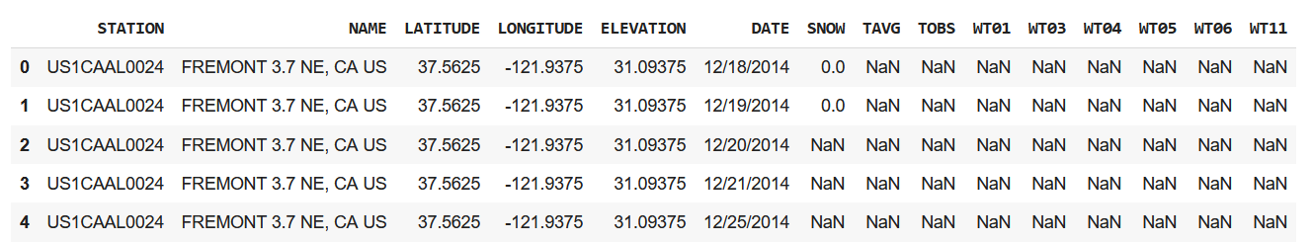

*Figure 90: Weather data head()*

We have first mapped location names to the store code and updated in the weather data frame and put 0 in the place of all null values in all columns except for TAVG and TOBS as they are related to temperatures. Following that, we have created a custom weather label based on the above data, the weather label takes the following classes by comparing certain conditions over the weather type columns and rest of the columns.

* 1 - Sunny day (Normal day)
* 2 - Cold, Freezy weather
* 3 - Stromy weather
* 4 - snowfall
* 5 - freezy snow fall

We have set Sunny day class as fill class for the days with no data for all stores for consistency. We isolated the weather label class, date and Store ID and pivoted the data to create the below frame.

Since the Weather class is a categorical column, we have converted to numerical labels for prediction reasons. We have pivoted data and kept store locations as columns in data frame because it will be easy to look at the store level data when forecasting. If we need to merge the data to appropriate date and store, it is possible to do by melting the data frame. By melting the data frame, all the store columns will be converted to rows as previous state.

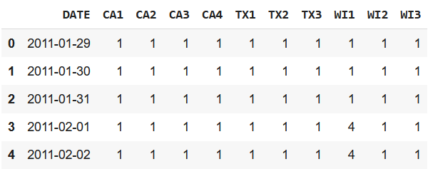

*Figure 91: Conversion of weather data to numbers*

**B.2 Median income**

Median Income is the second feature to be added before building the model. To get the data we have compiled the 2011-2012 income data and calculated median for higher level classes of income classes.Income data is available in 5.

We have considered 3 income classes

* Household income
* Family income
* Nonfamily Household income

Household income: The term household income generally refers to **the combined gross income of all members of a household above a specified age**. Household income includes every member of a family who lives under the same roof, including spouses and their dependents.

Census returns coming from the same residential address or household (excluding group quarters addresses) are grouped together for processing. The total of the income figures reported for all individuals at the same address is called the household income. Persons in households who are related by blood, marriage or adoption constitute family households, and the sum of their incomes is referred to as family income. Most used income measures deal with values at the household or family level rather than for individuals.

Non-family households are classified as poor.

We have obtained median income values based on the geographic locations (zipcodes). Mapped zipcodes to the store locations using the below table.

|  |  |  |
| --- | --- | --- |
| **Code** | **Location** | **ZIP Code** |
| CA1 | Long Beach | 90804 |
| CA2 | Los Gato | 95032 |
| CA3 | San Diego | [92107](https://www.ncdc.noaa.gov/cdo-web/datasets/GHCND/locations/ZIP:92107/detail) |
| CA4 | Fremont | [94536](https://www.ncdc.noaa.gov/cdo-web/datasets/GHCND/locations/ZIP:94536/detail) |
| TX1 | [Rockwall](https://www.ncdc.noaa.gov/cdo-web/datasets/GHCND/locations/ZIP:75032/detail) | 75032 |
| TX2 | [Frisco](https://www.ncdc.noaa.gov/cdo-web/datasets/GHCND/locations/ZIP:75033/detail) | 75033 |
| TX3 | [Sachse](https://www.ncdc.noaa.gov/cdo-web/datasets/GHCND/locations/ZIP:75048/detail) | 75048 |
| WI1 | [Watertown](https://www.ncdc.noaa.gov/cdo-web/datasets/GHCND/locations/ZIP:53094/detail) | 53094 |
| WI2 | [Mequon](https://www.ncdc.noaa.gov/cdo-web/datasets/GHCND/locations/ZIP:53092/detail) | 53092 |
| WI3 | [Theresa](https://www.ncdc.noaa.gov/cdo-web/datasets/GHCND/locations/ZIP:53091/detail) | 53091 |

After compiling the median data for the given store location, we have constructed the data frame, as below.

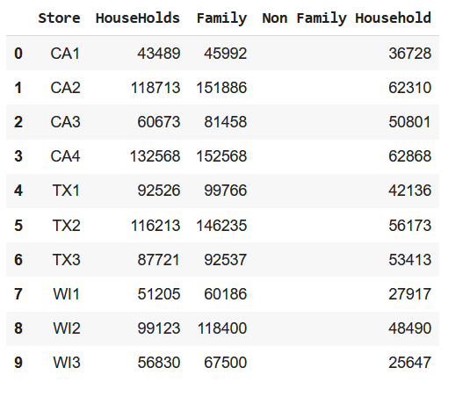

*Figure 92: Median Data Frame*

**C. Use the below machine learning algorithms to model n-step ahead forecasting (n = 10).**

C.1 Arima model:

**ARIMA** stands for **Autoregressive Integrated Moving Average Model**. It belongs to a class of models that explains a given time series based on its own past values -i.e.- its own lags and the lagged forecast errors. The equation can be used to forecast future values. Any ‘non-seasonal’ time series that exhibits patterns and is not a random white noise can be modeled with ARIMA models.

**ARIMA Models** are specified by three order parameters: (p, d, q) where:

* + p is the order of the AR term
  + q is the order of the MA term
  + d is the number of differencing required to make the time series stationary

An ARIMA model is one where the time series was differenced at least once to make it stationary, and we combine the AR and the MA terms.

a. Checking for stationary time series

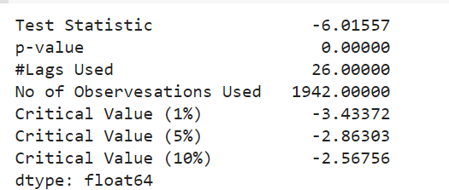

*Figure 93: Stationary Time Series*

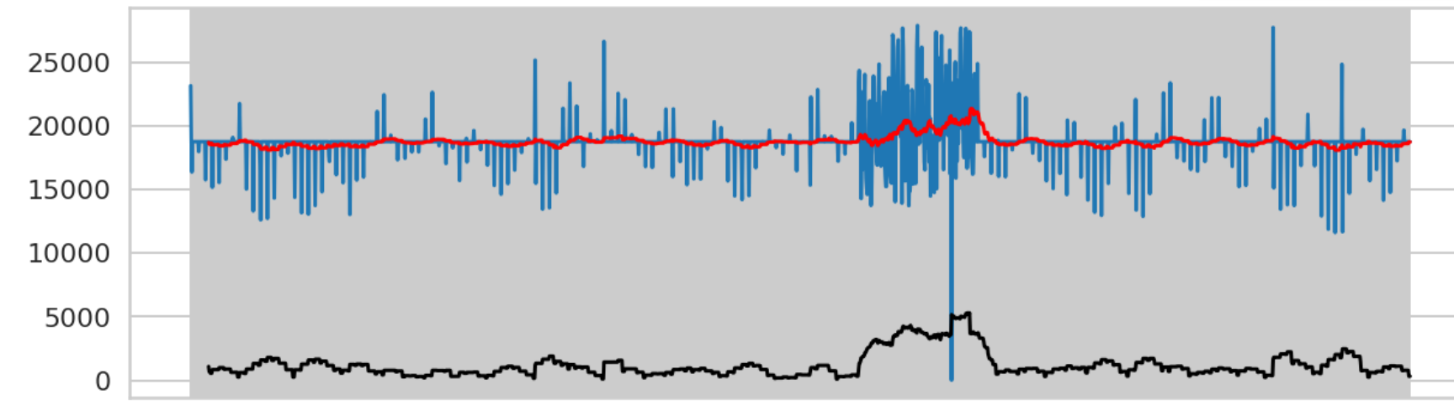

*Figure 94: Verifying if Time Series is stationary*

We can observe that Test Statistic is not below the 1% of the Critical value. So, Series is not stationary.

Hyper-parameter Tuning: The process of hyperparameter tuning entails determining a set of ideal hyperparameter values for a learning algorithm and then using this improved algorithm on data set.

We implement the Auto ARIMA model using the [pmdarima](https://pypi.org/project/pmdarima/) time-series library. This library provides the auto_arima() function that automatically generates the optimal parameter values.

In the auto_arima() function we pass the final_df which is our resampled dataset. We select the demand column since this is what the model wants to predict. The function can either use the Grid Search Technique or Random Search technique to find the optimal parameter values. It tries multiple combinations of p,d, and q and then selects the optimal ones.

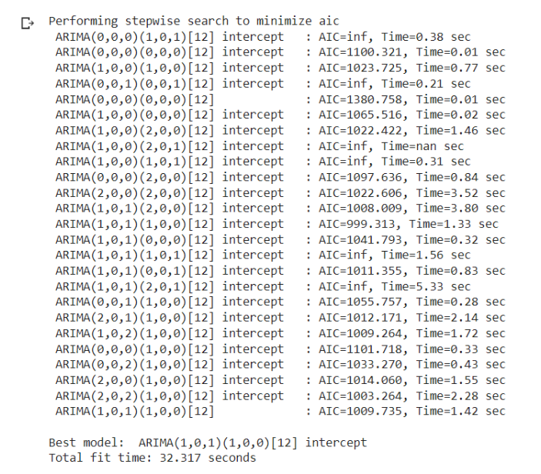

From the output above, the best model is ARIMA(1,0,1) (p=1, d=0, and q=1). The function automatically sets d=0 because the ADF test found the dataset is stationary. We had previously observed the time series dataset plots to have seasonality. Therefore, we thought the time series was non-stationary, hence a need for differencing. But using the ADF test, which is a statistical test, found the seasonality is insignificant. ADF test is more accurate than observing/visualizing the plots. That is why the function sets d=0, and there is no need for differencing.

b. Making time series stationary



*Figure 95: Making the time series stationary*

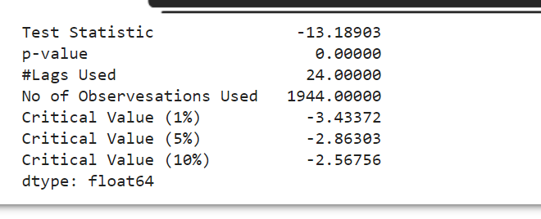

*Figure 96: Making the time series stationary*

We can observe that Test Statistic is way less than 1% of critical value. So, we can conclude that the above Series is 99% stationary. We fit the ARIMA model for the food series data with moving average for the food series. Below is the Actual vs predicted with RMSE differences.

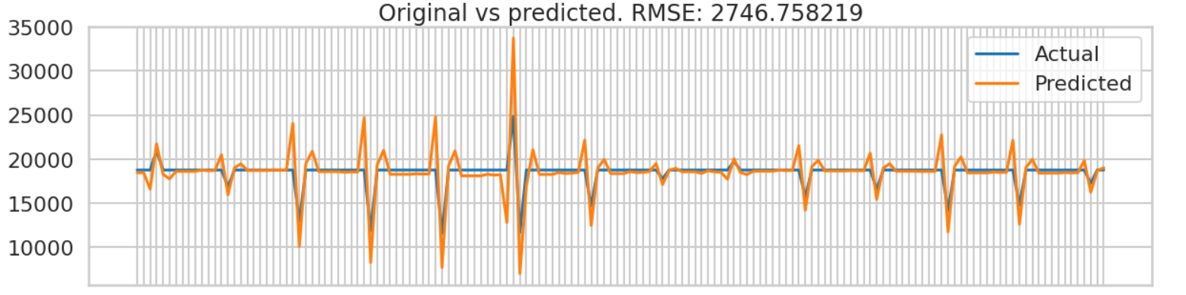

*Figure 97: Actual vs Predicted time series behavior*

**Long short-term memory (LSTM):** LSTM stands for long short-term memory networks, used in the field of Deep Learning. It is a variety of recurrent neural networks (RNNs) that are capable of learning long-term dependencies, especially in sequence prediction problems.

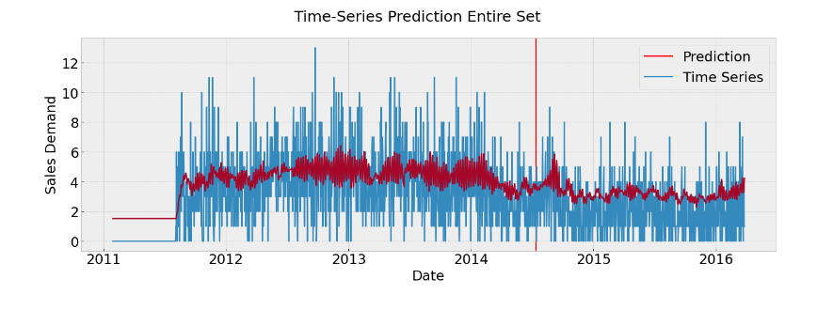

*Figure 97: Prediction of Time series between the years 2011 and 2016*

From the above plot we don’t have data for 2011 so it was a constant line when compared with other years.

Hyper-parameter Tuning: The process of hyperparameter tuning entails determining a set of ideal hyperparameter values for a learning algorithm and then using this improved algorithm on data set.

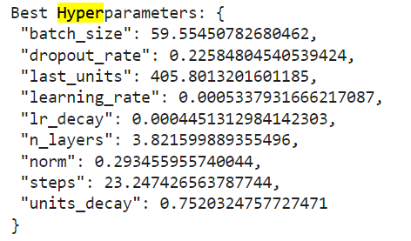

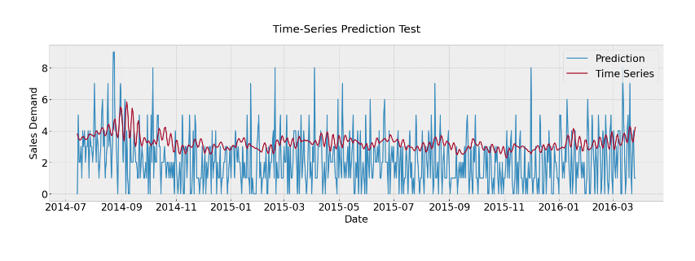

*Figure 98: Prediction of Time series*

We obtained an RMSE value of 2.0154672

## 

## **Sprint 3**

**Model Deployment and Business recommendation**

3.1 Deploying the winning model (ARIMA) from dataset_2 in Streamlit cloud

One of the most important steps after implementing the model is deploying the model and make them available to the end users or other components of the project. In our case, It is important to showcase the forecast results to end users to obtain meaningful insights on businesses.

Just like heroku, Streamlit is a cloud platform and API used to build apps that use ML Models with powerful features and lets us deploy quickly and make it available to internet. Streamlit apps are light weighted and user friendly and open source. It offers us to deploy, manage and share the application.

**Step – 1: Saving the model to disk using Pickle**

We have built 3 different models for each category (Foods, Hobbies, Household) for predicting sales using ARIMA. We have compressed and saved these 3 models to disk using pickle.

All three models take start date and end date as input for prediction and outputs the sales value for each date as a series.

**Step – 2 : Buidling a local streamlit Application and using the saved models**

We have built a streamlit app in local environment using Streamlit API documentation. The dashboard basically consists of

* Start date (date to start the forecast from)
* N number of days to forecast (n steps ahead future forecast)

The application will request the information in the UI. Once user clicks on Predict button, all inputs will be passed to model and predictions will be shown along with a sales prediction plot just as shown below.

The input start date only takes in between the data set date ranges and the n number days is limited to 31 days ~ 1 months because of performance of the web app.

**Step – 3 : Pushing the app to Github and deploying to streamlit cloud console**

After registering into streamlit cloud, we have created a new app and linked the github repo of the application and starting point and set runtime configuration of the app and ran the deployment. Now, the application is publicly available to internet. We have also included the data set reference in the application.

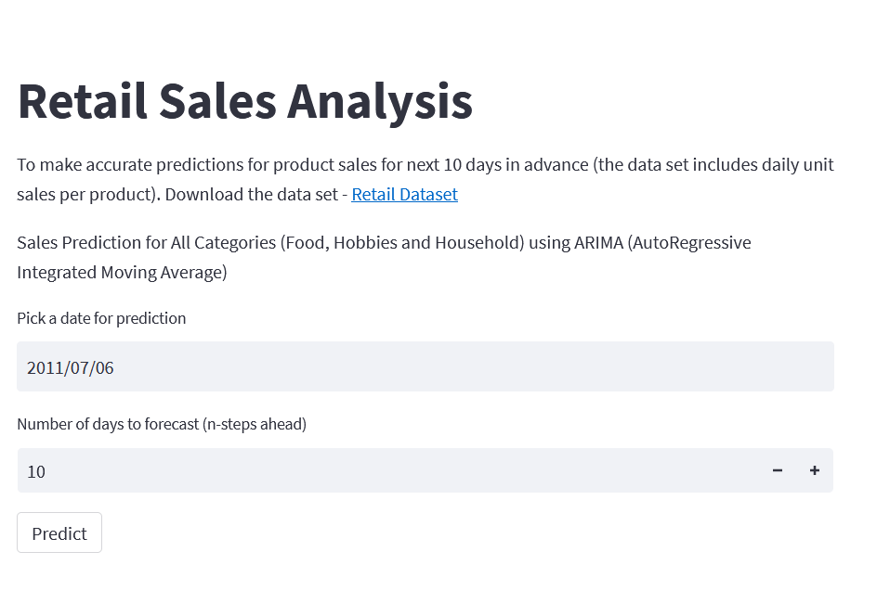

*Figure 99: Web App to display Sales forecast for all Categories*

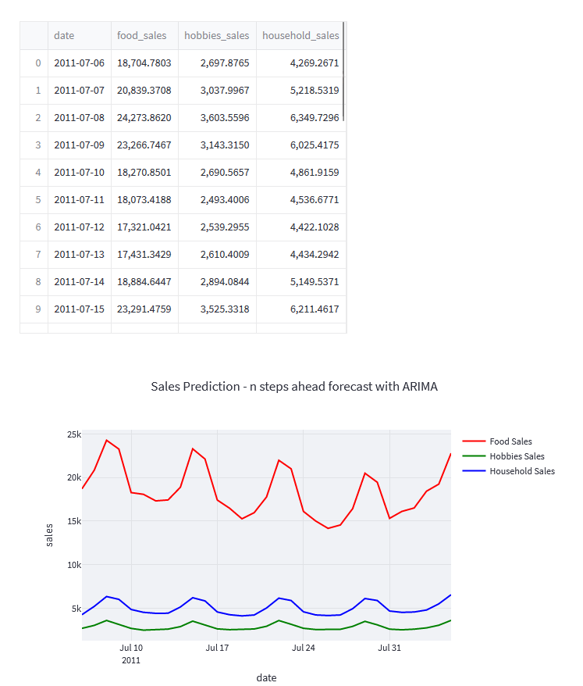

*Figure 100: Web App displaying the forecast for given time ranges*

App is deployed and is available in [Group 8 Streamlitapp](https://bhanusumanth-sprint3-app-j4lr7f.streamlit.app/)

**A. Perform ABC Analysis on Household Category for first year in the dataset.**

ABC analysis typically segregates inventory into three categories based on its revenue and control measures required. ABC Analysis is derived from the term The pareto Principle named after an Italian economist Vilfredo Pareto, also called 80/20 rule. This principle suggests that 80% of the total output is generated only by 20% of the valuable efforts.

The task is to perform product segmentation based on demand variability. Product segmentation refers to the activity of grouping products that have similar characteristics and serve a similar market. It is usually related to marketing (Sales Categories) or manufacturing (Production Processes). So our attention should be mainly focused on the sales volumes distribution (fast/slow movers), demand variability and delivery lead time.

The references that are driving most of the sales.

• Class A: Very Fast Movers: top 5%

• Class B: The following 15% of fast movers

• Class C: The remaining 80% of very slow movers

We have considered each item_id as an SKU (Stock Keeping Unit) Retail Jargon of product. SKU is used by retailers to identify and track its inventory, or stock. A SKU is a unique code consisting of letters and numbers that identify characteristics about each product, such as manufacturer, brand, style, color, and size.

First We have combined the calendar and Sales Train evaluation data set based on the day number column in both the tables. We have calculated and added 2 new columns.

* Mean
* Standard deviation

Mean and standard deviation of sales for 365 days for each product. We have **dropped the products with no sales in whole year** as they cannot bring much value in the analysis.

Example with product with item id - CA_1-HOBBIES_1_001 has 0 sales for the whole year. So, dropping such products.

The product count has dropped from ~30k to ~18k.

Following that, We have computed the net revenue generated based for each product to understand the demand. **Net Revenue = (Price of item x units sold).**

This is obtained by joining the sales price table with the net join of calendar and sales train table based on wm_yr_wk , day columns respectively.

Since we have both mean and standard deviation, we have calculated Coefficient of variation using the formula, **Coefficient of Variation = Standard deviation / Mean**

In probability theory and statistics, the coefficient of variation, also known as relative standard deviation, is a standardized measure of dispersion of a probability distribution or frequency distribution.

In order to perform the ABC Analysis, we need to consider the cumulative percent of revenue being produced for all products so that we can sort and plot a curve and classify products into class A, B , C.

Ideally, For SKUs with a high value of CV, you may face unstable customer demand that would lead to workload peaks, forecasting complexity and stock-outs.

Since we need to perform ABC Analysis on Household category, we filtered out household category and calculated mean, standard deviations , CV of sales, cumulative sales and sorted in descending order for ABC Analysis.

We have obtained the given class results based on each class expectation set above (5%, 15%, 80% of movers)

|  |  |  |  |  |
| --- | --- | --- | --- | --- |
| Class | Items | Cumulative | Revenue Percent | Cumulative Revenue % |
| A | 5% | 5% | 25% | 25% |
| B | 15% | 20% | 30% | 55% |
| C | 80% | 100% | 45% | 100% |

As per pareto principle, 80 percent of the output is determined by 20 percent of the input), they comprise a relatively small number of items but have a relatively high consumption value.

But, here 20% of items are not contributing as they are under 55% of input.

In this case, we cannot clearly observe the Pareto Law (20% of SKU making 80% of the turnover). However, we still have 80% of our portfolio making less than 50% of the sales.

The below plot represents clearly on the distribution percent of products over percentages of classes.

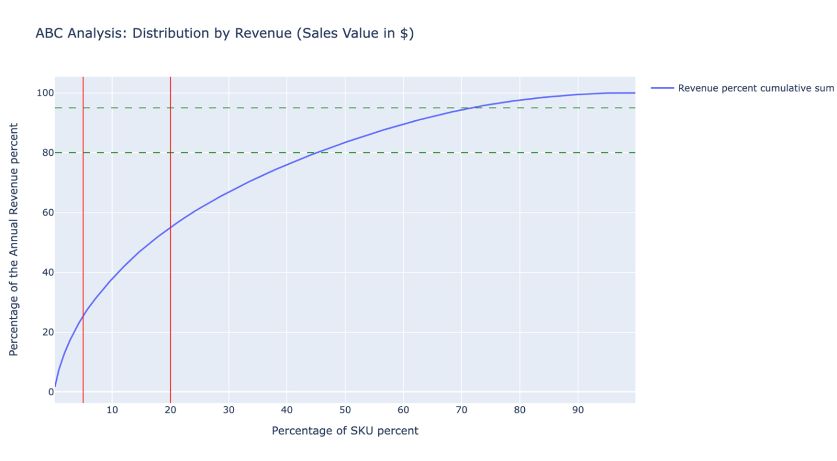 *Figure 109: ABC Analysis of Household Category data plot*

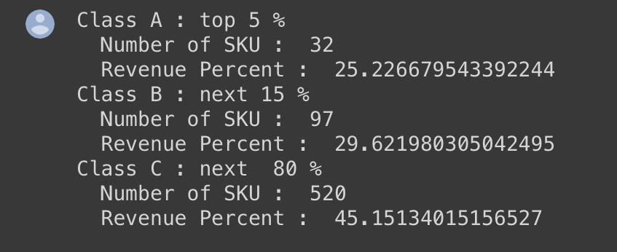

*Figure 110: ABC Analysis of Household Category*

Our top 20% of the items i.e. items in class A & B make up 55% of the total sales. According to our ABC analysis this does not follow Pareto’s law of 20% products making 80% of the revenue.

Surprisingly class C items i.e. least important items make 45% of the sales. This tells us that we need to monitor these items to if we need to manage our inventory optimally.

**B. Coefficient of variation**

**Distribution by demand variability**

We compute the coefficient of variation of the yearly distribution of sales for each reference to determine which products will provide planning and distribution difficulties.

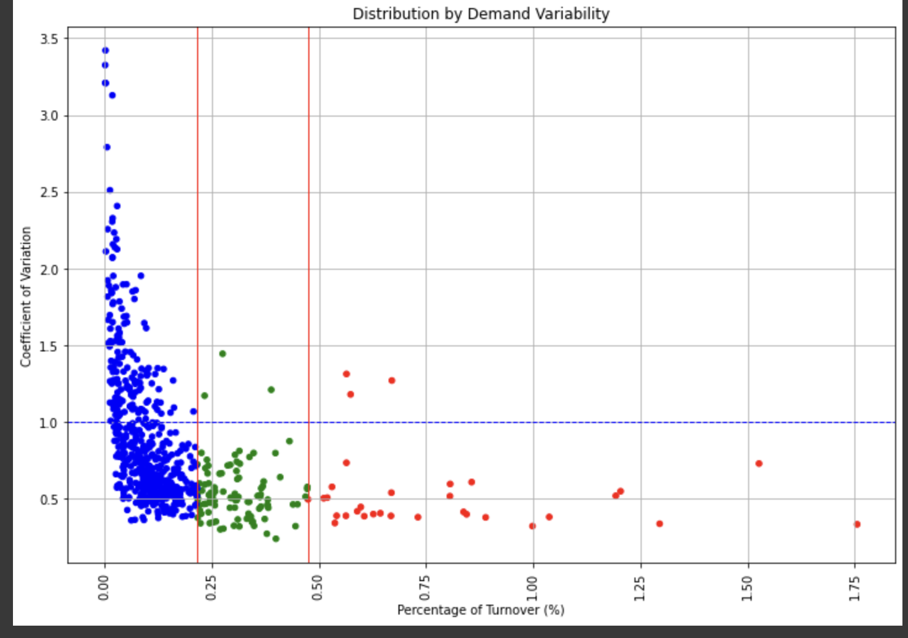*Figure 110: ABC Analysis*

## We analyze the graph for each class:

**Class A** (Red) : the majority of A SKUs have very consistent demand, so we won't face any difficulties from the most significant SKUs. Only a few items have high coefficient of variation.

**Class B** (Green) : The majority of SKUs are stable, but we continue to put effort into making sure that the few references with significant CVs have the best planning possible.

**Class C** (Blue) : For this type of reference, a cause analysis would yield better results than a statistical method to forecasting because the majority of SKUs have large CV values.

In previous section, we created ABC analysis. ABC inventory management is the standard way of stock management. On the other hand, there are multiple factors to be considered in stock management other than stocking up on the most popular products.

In real world scenario, demand for any product is bound to change over time. It could be seasonal changes or other factors such as product’s shelf life, economic factors such as median income, competitor activity, or discounts. This is where XYZ inventory management comes in. Unlike ABC inventory management, which looks at the revenue contribution of each SKU, XYZ inventory management classifies SKUs according to the variability of their demand.

With XYZ inventory management, the sales demand for each SKU is measured over a long period of time, in order to capture seasonal variations in demand, then the variance is calculated for each SKU and scores are ranked according to their variability.

**Class X**: Products assigned to Class X are those which show the least variation in demand. Sales of these products are fairly constant.

The histogram shown below, shows demand variability of a product that is categorized as class X which means it has fairly constant demand.

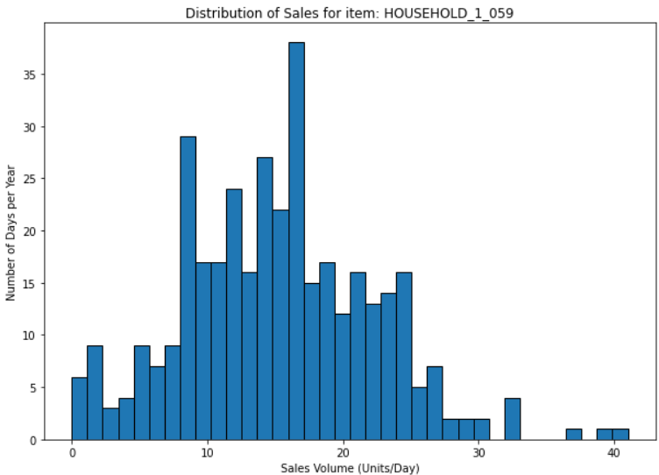

*Figure 111: X class demand per day*

**Class Y**: Products assigned to Class Y are more variable than those in Class X. Demand can change over time, due to factors like seasonality, so they’re harder to accurately forecast.

Histogram for demand variability of a product under category Y is shown below.

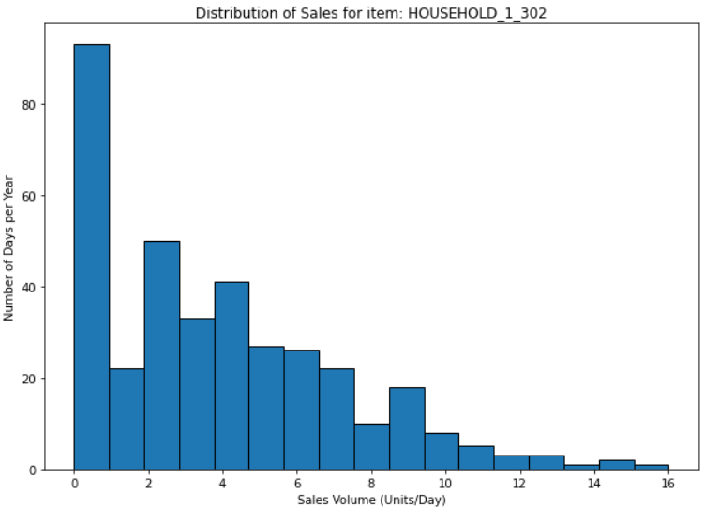

*Figure 112: Y class demand per day*

**Class Z**: Finally, Class Z products are highly variable. Demand goes up and down and is really hard to predict, so avoid stock outs can be really challenging.

Histogram for demand variability of a product under category Z is shown below.

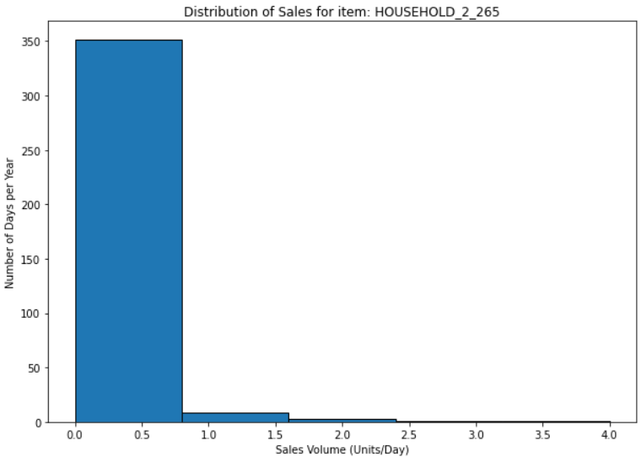

*Figure 113: Z class demand per day*

**C. Recommendations**

1. The XYZ analysis in combination with ABC, can have different interpretations [8].
   1. Products under category A and X have high value and steady consumption which is why it is easy to plan and stock up on such products. It is recommended to always plan and stay stocked up on such products as product going out of stock will result in loss of revenue.
   2. Products under categories B and C with X category demand variability have moderate or low value and constant demand. Products having moderate or low value but constant demand will also bring steady revenue which is why it is recommended to plan and always keep these products in stock as long as they follow the same sales pattern.
   3. Products under category A or B along with Y or Z category demand variability have high value and fluctuating demand. To forecast the sales of such products can be difficult. In this case, stocking up or ordering the product on demand is recommended as that will prevent any losses from unsold products as well as secure the revenue.
   4. Products under category C along with Z category demand have low value and irregular demand. Here the proper investigation of the product demand is needed. For example, low value items can be in demand as per the seasons or holidays. In such cases procurement of such products has to be planned and product should be in stock when the demand increases. It is also important to evaluate the cost of storing the product and cost of the procurement as compared to the potential revenue.
2. After ABC analysis we observe that out of 649 item the 32 items in class A drive a lot of sales and constitute for 25% revenue of the total revenue. These smaller number of items are the most important and need the highest priority and care. Since these will the driving most amounts profits from a business owners perspective. Class B has 97 items and have 29% of the total revenue. These are mid-tier items with total and have medium revenue. These items have less priority than class a items. Lastly class C has high volume of items i.e. 520 out of 649. And constitute for 44% of the total revenue. This does not follow Pareto’s law clearly which is 20% of sku making 80% of total revenue. In our case its only 55%. So we need to consider class c items as equally important since the can affect the revenue by 45%. We need to optimize the business so that items in class A & B can have 80% or above turnover. Some recommendations to do this would be as follows:
   * Better pricing for items in Class A & B: we know for a facts that these items are in high demand since such small type of items generate over half of the revenue. If we can offer better pricing to the customers for these products. If we lower the prices than the competitors the total revenue generated by class A and Class B items is bound to increase giving us that 80% of total revenue.
   * Class A items account for 25% of our income, thus it makes sense to bargain with suppliers for better terms on those items. We can try negotiating post-purchase services, down payment reductions, free delivery, or other cost savings if the provider won't agree to lower prices.
   * To make sure that Class A items are in line with client demand, resource allocation is regularly assessed using ABC analysis. Reclassify the item when demand declines to better utilize staff, resources, and space for the new Class A products.
3. Inventory and Revenue for State and Category:

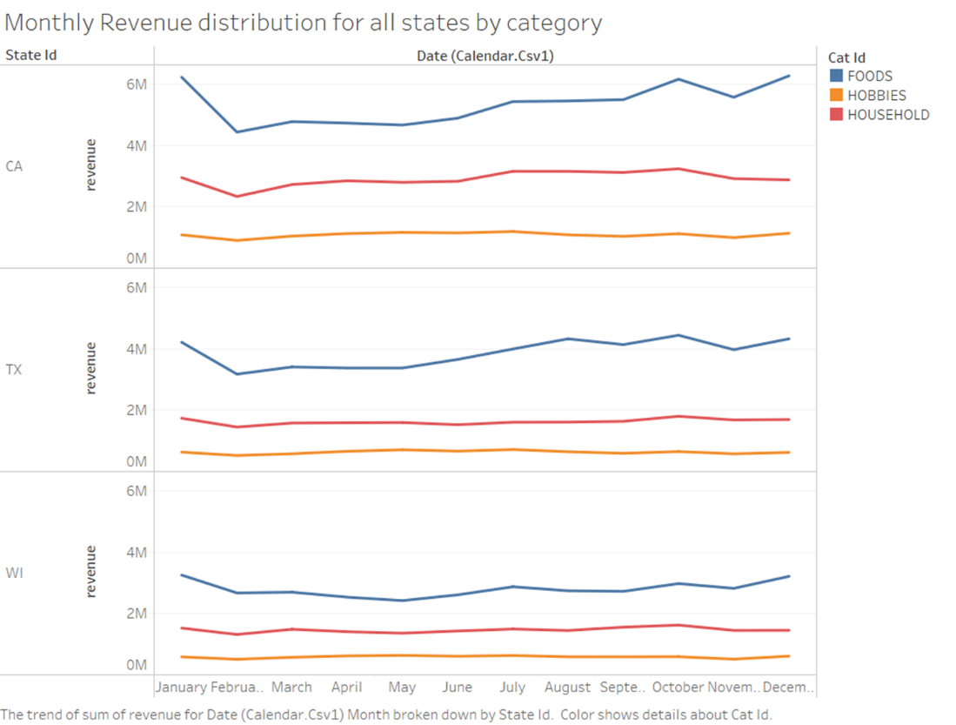

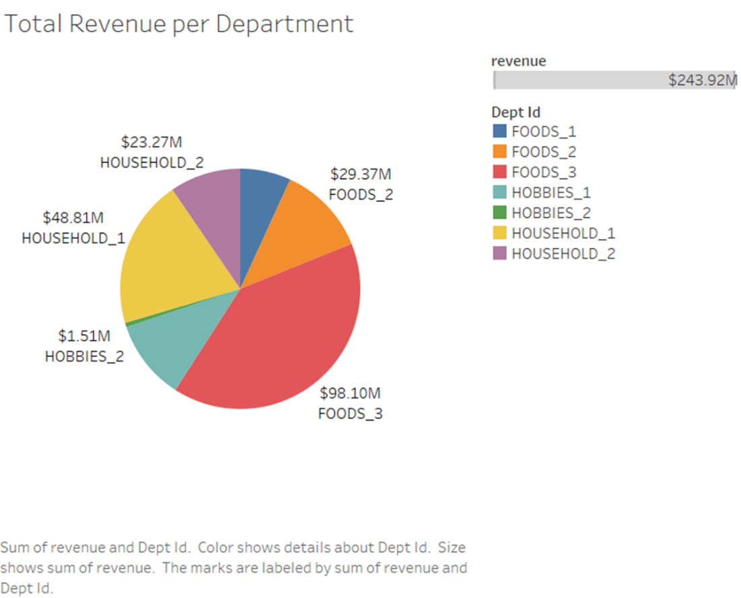

The above charts clearly showcase that the state of California generated the highest amount of revenue out of all the states with consistently reaching 8-9 Million dollars of revenue per month. Out of which food items generated more that 50% of the total income for all the states.

A good recommendation would be to allocate more resources to food category items, this can be done by improving handling and care condition of these items in the warehouses. Improving quality of these product so we create a loyal customer base. Decreasing costs on these items by supplier negotiations based on order quantity. This will lead to a higher profit margin due to lower making costs.

1. Boost sales during Events:

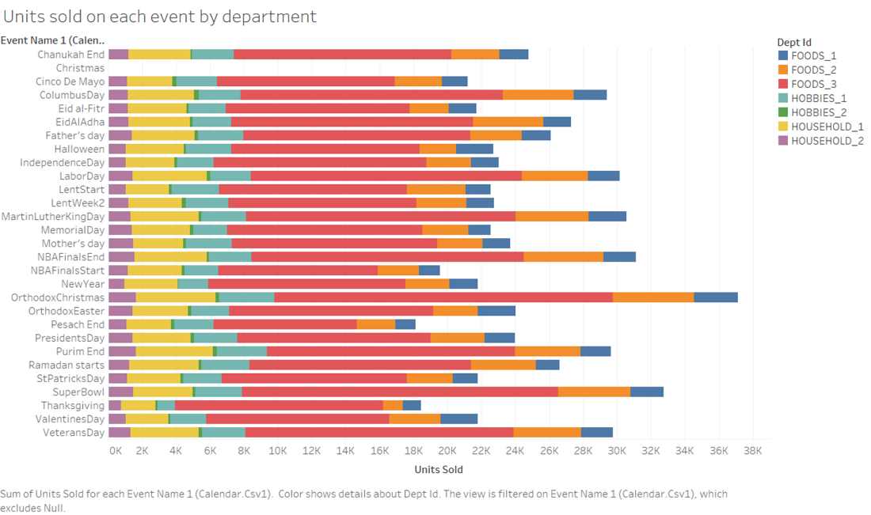

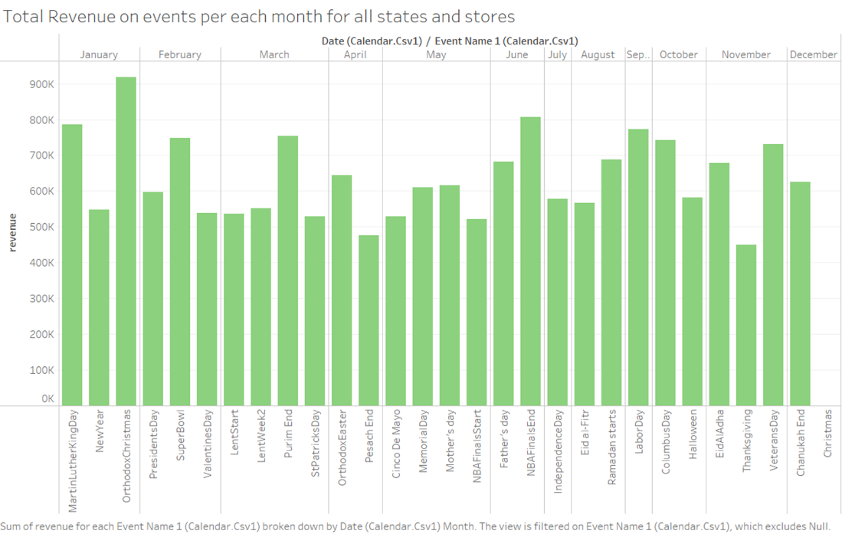

We observed higher number of units sold during various religious, festive and national events across the year in all the states for all the item categories. During these events the revenue surpasses 900k in a day and was averaging at about 500k per day. These type of events are a blessing for businesses to make as much profit as possible. Companies should be well equipped to take advantage of these days. Business recommendation for this scenario would be as follows:

* Most of the competitor companies would follow the orthodox of proving equal discounts across all the stores in all areas. However to stand out from the competition all the locations of the stores need to be examined and the discounts given should be based on factors like median income of the population in each of the particular region. For example if the general discount provided for all the stores during these events is 10% then areas with low median income must be provided with 15-20% discount on prices so that people from these regions would be easily able to afford store products resulting into more people flocking into stores consequently driving sales and generating more revenue. On the other side of the spectrum areas with high income the discount can be reduced to 5% since the purchasing power of the general consensus is much higher.

1. It is clearly seen that the products sold during the weekends are much higher than the products sold during the weekdays. The below figure clearly indicates that Sunday and Saturdays are the highest shopping days and more demand days from rest of the days. In addition to that, CA has the moderate median income of all 3 states (CA, TX, WI) over Households, non households and Family Categories.

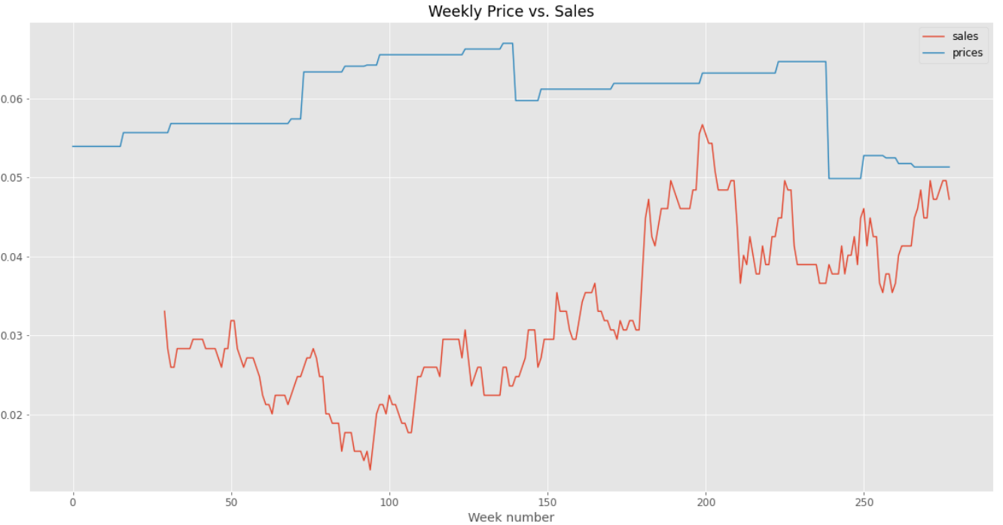

The price variations can also be seen over for 2-3 weeks. Within the whole data set. It is clear that price has been consistently increased till week number 220 and drastically dropped and started increasing after week 235. In order to have consistent sales over weeks, despite price increase, by increasing the price on weekdays and decreasing price of SKUs to 5-10% of overall increase level, It will increase sales and revenue.

## References

1. Rokach, L. (2005). Ensemble Methods for Classifiers. In: Maimon, O., Rokach, L. (eds) Data Mining and Knowledge Discovery Handbook. Springer, Boston, MA.
2. <https://www.analyticsvidhya.com/blog/2018/06/comprehensive-guide-for-ensemble-models/>
3. <https://developer.ibm.com/articles/stack-machine-learning-models-get-better-results/>
4. <https://www.ncdc.noaa.gov/cdo-web/search>
5. <https://data.census.gov/table?q=ZCTA5+90804+Income+and+Poverty&tid=ACSST5Y2020.S1903>
6. <https://bhanusumanth-sprint3-app-j4lr7f.streamlit.app/>
7. [Xyz analysis](https://t2informatik.de/en/smartpedia/xyz-analysis/#:~:text=The%20findings%20of%20a%20XYZ%20Analysis&text=The%20classes%20are%20calculated%20using,and%20for%20Z%20over%2050%25.)
8. [Demand variability](https://practicaldatascience.co.uk/data-science/how-to-create-an-abc-xyz-inventory-classification-model)